

*The Newsletter*

Article No.2 Headline Goes Here

By: Anonymous

This space holds approximately 160 words (with pull quote). Adipiscing elit. Curabitur faucibus lectus eget risus fringilla volutpat pulvinar libero tristique. Nullam id nisi augue. Cras bibendum aliquam lorem, eget accumsan mi consequat nec. Ut tristique convallis porta. Aliquam eget justo urna.

Vestibulum tristique turpis eu nisi vehicula lacinia. Maecenas id sollicitudin magna. Vivamus rutrum nulla mi, quis pellente.

Lorem ipsum dolor sit amet, consectetur adipiscing elit. Curabitur faucibus lectus eget risus fringilla volutpat pulvinar libero tristique. Nullam id nisi augue. Cras bibendum aliquam lorem, eget accumsan mi consequat nec. Ut tristique convallis porta.

Curabitur faucibus lectus eget risus fringilla volutpat pulvinar libero tristique. Nullam id nisi augue. Cras bibendum aliquam lorem, eget accumsan mi consequat nec. Ut tristique convallis porta. Aliquam eget justo urna. Nulla viverra justo a odio volutpat sollicitudin. Vivamus nec metus urna, vitae scelerisque quam. 

October 2012

Volume I • Issue 1

Page 1

Article No.1 Headline

Page 2

Article No.2 Headline

Article No.3 Headline A Little Longer Still to Add Variety

Publication & Contact Information

Page 3

President’s Message

Article No.5 Headline A Little Longer Still to Add Variety

Page 4

Article No.6 Headline

CONTENTS

Article No.1 Headline Goes Here

By: Anonymous



This space holds approximately 210 words (with image in space above). The main font is Adobe Garamond Pro Semibold, set for headlines in medium purple and 8pt size. The body font chosen for this newsletter is Trebuchet Regular set in 9pt and 85% Black. This column holds approximately 160 words before breaking onto the next page.

Lorem ipsum dolor sit amet, consectetur adipiscing elit. Curabitur faucibus lectus eget risus fringilla volutpat pulvinar libero tristique. Nullam id nisi augue. Cras bibendum aliquamlorem, eget accumsan mi consequat nec. Ut tristique convallis porta. Aliquam eget justo urna. Nulla viverra justo a odio volutpat sollicitudin. Vivamus nec metus urna, vitae scelerisque quam. Nunc eget tortor non lectus luctus adipiscing. In hac habitasse platea dictumst. Nullam id nisi augue. Cras bibendum aliquam lorem, eget accumsan mi consequat nec. Aliquam eget justo urna.

Vivamus nec metus urna, vitae scelerisque quam. Nunc eget tortor non lectus luctus adipiscing. In hac habitasse platea dictumst. Nullam id nisi augue. Cras bibendum aliquam lorem, eget accumsan mi consequat nec. Aliquam eget justo urna. Nullam id nisi augue. Cras bibendum aliquam lorem, eget accumsan mi consequat nec. Aliquam eget justo urna.

Continued on page 2

Lorem ipsum dolor sit amet, consectetur adipiscing elit. Curabitur faucibus lectus eget risus fringilla volutpat pulvinar libero tristique. Nullam id nisi augue. Cras bibendum aliquam lorem, eget accumsan mi consequat nec. Ut tristique convallis porta. Aliquam eget justo urna. Nulla viverra justo a odio volutpat sollicitudin.

Pull quote here in Trebuchet bold italic, 10pt.

Vivamus nec metus urna, vitae scelerisque quam. Nunc eget tortor non lectus luctus adipiscing. In hac habitasse platea dictumst. Cras bibendum aliquam lorem, eget accumsan mi consequat nec.

Curabitur faucibus lectus eget risus fringilla volutpat pulvinar libero tristique. Nullam id nisi augue. Cras bibendum aliquam lorem, eget accumsan mi consequat nec. Ut tristique convallis porta. Aliquam eget justo urna. Nulla viverra justo a odio volutpat sollicitudin. Vivamus nec metus urna, vitae scelerisque quam. Nunc eget tortor non lectus luctus adipiscing. In hac habitasse platea dictumst. Cras bibendum aliquam lorem, eget accumsan mi consequat nec. Nunc eget tortor non lectus luctus adipiscing. In hac habitasse platea dictumst. Nunc eget tortor non lectus luctus adipiscing. In hac habitasse platea dictumst.

Aliquam eget justo urna. Nulla viverra justo a odio volutpat sollicitudin. Nullam id nisi augue. Cras bibendum aliquam lorem, eget accumsan mi consequat nec. Ut tristique convallis porta. Aliquam eget justo urna. Nulla viverra justo a odio volutpat sollicitudin. Vivamus nec metus urna, vitae scelerisque quam. 



**1 • The Newsletter • October 2012**

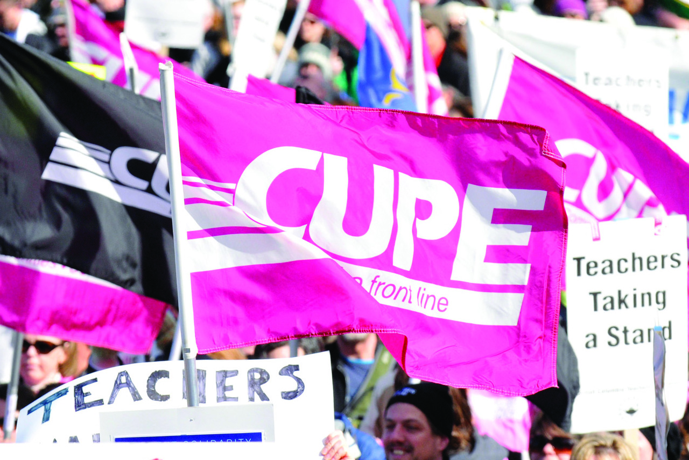

Tips for New and Young Workers

Courtesy The Canary, CUPE’s health and safety newsletter

All workers face a higher risk of injury in the first six months of a job, as they may be unaware of existing or potential risks. In just two years (2007-09), 124 workers between the ages of 15 and 24 years died from work-related injuries in Canada.1

Questions to Ask Your New Employer

To start things off on the right foot, ask your new employer to give you a health and safety orientation to your worksite. Here are some questions to ask:

1. What are the hazards of my job?
2. What training will I receive?
3. Is there safety equipment I’ll be expected to wear?
4. What do I do if I get hurt?
5. Who do I go to with safety concerns?

Is your workplace unsafe?

Though it is the primary responsibility of your employer to provide a healthy and safe workplace, we must not be complacent. Here are some signs that your workplace may be unsafe:

* Other workers are being injured on the job.
* You’re working without direct supervision.
* You haven’t been trained properly.
* Equipment is unguarded and/or broken.
* Containers of chemicals aren’t labeled.

Safety shortcuts are used to save time or money.

Poor housekeeping and maintenance (like slippery floors, frayed electrical cords) are present and not fixed when reported.

Ways to Protect Yourself at Work

* Learn about your rights and obligations under the applicable legislation in your jurisdiction.
* Take advantage of the training you are given, learn to do the job safely, and don’t perform tasks or use equipment that you have not been trained to use.
* Think the job through; know what to do when there is an injury or emergency.
* Get help, especially if you have to lift something heavy or are not sure how to do a task that may be dangerous.
* Wear the safety gear that is required to do your job safely.
* Tell your supervisor if you see any hazards or violations.
* Talk to your coworkers, friends and even your family about your job; they might know something you don’t!

Other job-related factors include lack of training and supervision, unsafe equipment, stressful conditions and working too quickly.

**Want to know more?** Check out the full, downloadable fact sheet at   
cupe.ca/health-and-safety/new-workers

[This space holds approximately 400 words] 

1Association of Workers’ Compensation Boards of Canada <http://awcbc.org/en/youngworkerresourcesinformation.asp>

Article No.1 Headline

continued from page 1

**2 • The Newsletter • October 2012**





Events

* Header goes here in Trebuchet 12pt in purple

For the event details use style Local News & Events: Details.

* Header No.2

For the details use style Local News & Events: Details.

**3 • The Newsletter • October 2012**



Local News

* Sub header goes here in Trebuchet 12pt in purple

Details start on next line in Trebuchet Regular 10pt in 80% Black.

* Header No.3 is a Little Bit Longer

Local News: Details is the Style for this text. This is filler text pay it no mind. Details continue onto third line.

* Header No.4 is Even Longer Still Because it Has More Words

Details go here, again, with style Local News: Details applied. This can be as long as you want, but if it exceeds 100 words, you should consider making it it’s own article.

* Header No.4 Local News

You can lengthen this section and shorten the Events section below, if you require more space.   
To fill-up unused space, insert an image.

President’s Message



Reflections on a Year of Public Engagement

Welcome to the first issue of our new newsletter, which will be produced three times a year.

First of all, I’d like to wish all our members a happy and healthy New Year. Last year was very special for us, as we celebrated our 70th Anniversary. It was also a challenging year, opening with tense negotiations with an administration that simply refused to negotiate. The bargaining committee would like to thank all our members for your strong support and encouragement during that difficult process. However, 2012 was also a very special year. Our publicity campaign reached new heights through a award-winning advertising and community engagement that helped build awareness of, and support for, our local’s members.

Our members’ services were also a visible presence across the city as we lent our support to community events like the Canadian Cancer Society’s Relay for Life, the Pride Flag Raising at City Hall, the Pride Parade, the Dragon Boat Races, the Festival of South Asia, our 70th Anniversary Summer Picnic, and more. Our misting tent was a hit, and people loved the water bottles that we gave out with information about the many services that our members provide.

Last year saw the highest-ever level of engagement by our local’s members. Hundreds of our members got involved in advocacy and political campaigns, and our first-ever e-mail campaign resulted in increased provincial funding for childcare. Engaging with the public and working with community partners makes a difference.

Enjoy reading the new newsletter! Participate in our competition to win prizes, and please give us feedback. By working together in solidarity I know we will continue to grow and face whatever challenges lie ahead.

In solidarity, your president   
CUPE 9999   
twitter: @twitterhandle 

 Approximately 350 words (with pull quote). 

Vacation: It’s yours to use

Without a union, you might start with just two weeks of vacation. Our collective agreement (CA) starts new hires with three weeks and provides more days as we gain seniority—up to six weeks per year, plus bonus days after 10, 15 and 20 year anniversary years.

And don't forget, the break between Christmas Eve and New Year’s was negotiated by your union on your behalf!

We also have a provision for carrying over up to 10 vacation days into to the next calendar year.

Some members have asked, “What happens if I have more than 10 days to carry over? Do I lose the extra days?”

The answer is NO! You cannot lose your vacation days.

Here’s why: Clauses 20.02 and 20.03 of the CA dictate that we are to be informed of our vacation entitlement each February, that vacation schedules shall be determined by mutual agreement and seniority, that we will be informed in October of any unused vacation, and that there is a process and a form to carry over any remaining vacation days.

These clauses put the onus on the employer to ensure our vacations are being scheduled, and that carry-over forms are submitted.

Here’s another important point: The CA does not say vacation may be carried over, it says “the remaining entitlement will be carried over to the following year.” And then it goes on to say, “With mutual agreement, such vacation entitlement may be converted to additional pay.”

But nowhere does it say you lose unused days.

We negotiated vacation because vacation is important to our health, our families, and our ability to do our jobs effectively. But workload and resources being what they are, sometimes things come up. Our managers are busy and over-worked too, so sometimes details can be overlooked. That said, if for any reason you have more than the allotted 10 days to carry over or if you believe you’ve lost out on any vacation, whether it’s because of too much carry-over time, or failing to submit the carry-over form, contact the union office or a union steward.

They will ensure you receive your full vacation allotment, either as carry-over or as a cash payout. 

Approximate word count = 400. Remove image at top to make more room for text.]

National News

Asking the right questions on P3s

Greg Taylor, CUPE communications

A new guide encouraging municipal leaders and officials to show caution when considering the use of public-private partnerships to finance public infrastructure projects is now available.

The guide - *Asking the Right Questions: A Guide for Municipalities Considering P3s* - probes the many issues surrounding P3s, providing insight and tools for local governments and infrastructure advocates. It outlines the problems that accompany infrastructure and service privatization, and highlights the value of keeping vital assets and services public.

“After they read this guide, I’m sure mayors and city councilors will think twice about rushing headlong into pro-privatization initiatives and agree with us that P3s do not offer all the benefits touted by their promoters,” said Paul Moist, national president of CUPE, while unveiling the new guide at a press conference in Regina, SK. He was joined by Charles Fleury, national secretary-treasurer of CUPE, and the guide’s author, Dr. John Loxely. “In terms of costs, risk sharing, service quality, infrastructure maintenance, and the impact on workers, communities and the local economy, the detailed responses in this guide will equip municipalities to review the facts carefully before entering into a P3,” explained Dr. Loxley, professor of economics at the University of Manitoba.

An electronic version of *Asking the Right Questions: A Guide for Municipalities Considering P3s* is available for download at cupe.ca/p3guide. Print copies of can also be ordered through this link.

[Approximate word count = 250]

Contract Corner



**4 • The Newsletter • October 2012**