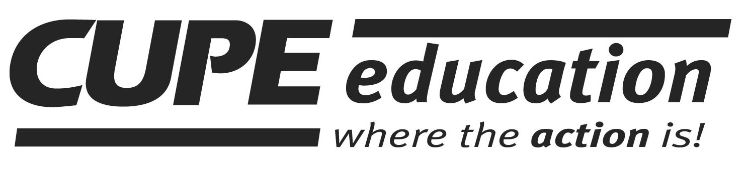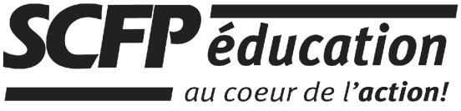
Prince Edward Island / Île-du-Prince-Édouard
2017-2018

REGISTRATION FORM / FORMULAIRE D’INSCRIPTION

Workshop / Atelier : Building Strong Local Unions Location / Endroit : CUPE Charlottetown
26 Paramount Avenue, Charlottetown, PE C1E 0C7

Workshop Date : February 14-15, 2018 Time / Heure : Day 1 - 9:00 to 4:00 / Day 2 - 9:00 to noon
Deadline / Clôture : February 7, 2018

PLEASE PRINT CLEARLY • VEUILLEZ SVP IMPRIMER
Name / Nom | Email / Courriel | Telephone | Local #  Section locale

REGISTER ONLINE AT: www.cupe.ca RETURN BY EMAIL: maritimeseducation@cupe.ca OR FAX: 506-452-1702

CUPE MARITIME REGIONAL OFFICE - 91, Woodside Lane, Fredericton, NB E3C 0C5

