

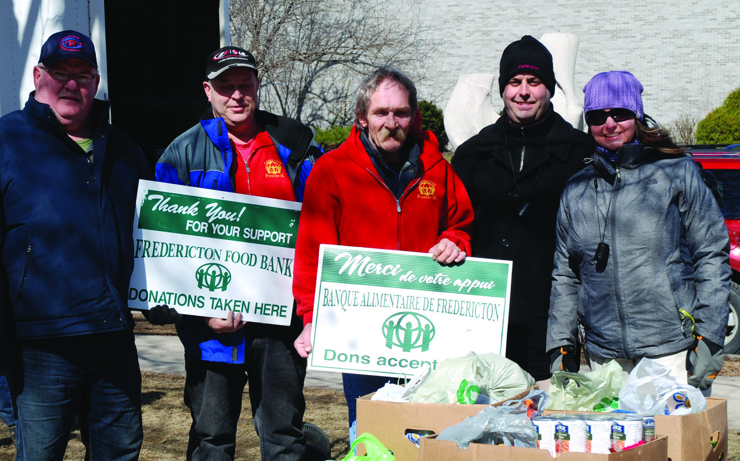

Article No.1 Headline Goes Here

By: Anonymous

A basic article (such as this) has a headline that can stretch across the whole width of the column, and take up as many lines as it requires. Headlines are set at: Archer Medium, 20pt with a space after of 4pt. Following the headline is the by-line, where you would type the author’s name. The by-line is set at: Archer Book, 12pt with a space after of 8pt. Body copy for a basic article is set as: Arial Regular, 8.5pt in 100% Black. The paragraphs have a space after of 10.5pt.

If you want to feature a pull-quote in your article to either highlight an important point or quote,   
or even just to fill-up space if your word count is a little short, follow the style below as-is:

This is an example of a pull-quote. The text is stylized   
here as Archer Medium Italic, 12pt. Break the lines   
manually by hitting Shift + Enter on your keyboard  
to create a more visually appealing block of text.

This article is laid out in one column because the entire article fits on this first page. A good rule   
for this is if your word count totals less than 400 words, go with a one-column layout. If it has less than 300, use a few lines as a stylized pull-quote to fill-up space.

If there were a continuation of this article onto another page, the difference then would be to create a two-column grid here instead. We have not justified the text because the result may be unappealing. It is much more organic-looking to have natural line breaks down the right side of the column, so we set our text aligned-left. Use a little icon such as the one to my right to symbolize an end to any basic article.

Aliquam magna neque, faucibus vitae luctus sed, faucibus dapibus sapien. Sed elit turpis, vulputate quis venenatis quis, vulputate vel felis. Nunc eget lorem vel quam consectetur scelerisque in adipiscing lorem. Etiam interdum sapien quis ligula molestie non dictum dui semper. Donec commodo, lorem a tincidunt adipiscing, purus purus interdum sem, nec consectetur diam urna eget neque.  [Approximate word count = 375]

1 The Newsletter



IN THIS ISSUE:

The Newsletter

Volume 1 | Issue 1

Monday, October 29, 2012

**1**

Article No.1 Headline

**2**

Article No. 2 Headline

**2**

Article No.3 Headline Is A Bit Longer

**2**

CUPE Presents

**3**

Article No.4

**3**

Article No.5 Has A Long Name

**4**

Article No.6 Has A Long Name As Well

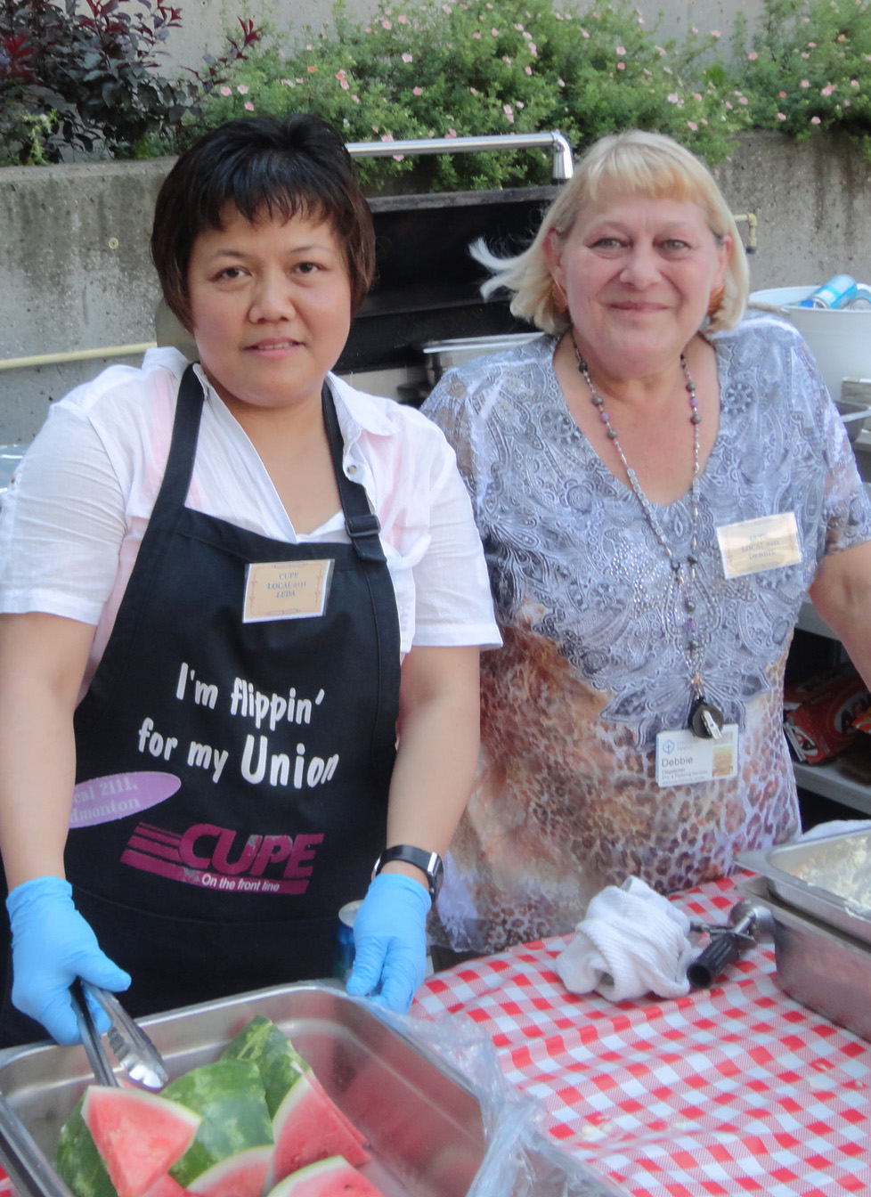

Article No.2 Headline

By: Anonymous

This article space has room for an approximate word count of 200, including headline and by-line.

Lorem ipsum dolor sit amet, consectetur adipiscing elit. Nunc sed justo urna, a congue libero. In vel purus arcu. Vestibulum tempor ipsum in nibh viverra egestas. Aliquam molestie pellentesque erat, eu euismod nisi tempor in. Pellentesque congue egestas congue. Integer sed libero felis. Praesent fringilla adipiscing eleifend. Aliquam ultricies placerat tellus at eleifend. Nulla id arcu vel sapien pharetra luctus.

In hendrerit facilisis tortor at mattis. Aenean nec lacinia felis. Proin tempor lacus eu urna ullamcorper vel pulvinar velit pharetra. Aliquam magna neque, faucibus vitae luctus sed, faucibus dapibus sapien.Nunc eget lorem vel quam consectetur scelerisque in adipiscing lorem. Etiam interdum sapien quis ligula molestie non dictum dui semper. Donec commodo, lorem a tincidunt adipiscing, purus purus interdum sem, nec consectetur diam urna eget neque.

Integer a arcu a arcu vulputate tincidunt. Fusce ac velit eu ipsum posuere placerat. Donec a nulla eu mauris viverra commodo. Vestibulum vitae mattis tellus. Duis eget justo quis sapien suscipit tempor ut at metus. Nam rutrum volutpat ullamcorper. Donec a nulla eu mauris viverra commodo. Vestibulum vitae mattis tellus. Duis eget justo quis sapien suscipit tempor ut at metus. 

Visit us online at www.cupe.ca to read and share this article online.

Article No.3 Headline is a Bit Longer and there is No Image

By: Anonymous

Sometimes it’s nice to give a special treatment to the lead-in sentence of an article, if it reads well.

This article space has a maximum word count of 200 words, including headline and by-line. Lorem ipsum dolor sit amet, consectetur adipiscing elit. Nunc sed justo urna, a congue libero. In vel purus arcu. Vestibulum tempor ipsum in nibh viverra egestas. Aliquam molestie pellentesque erat, eu euismod nisi tempor in. Pellentesque congue egestas congue. Integer sed libero felis. Praesent fringilla adipiscing eleifend. Aliquam ultricies placerat tellus at eleifend. Nulla id arcu vel sapien pharetra luctus.

Aliquam magna neque, faucibus vitae luctus sed, faucibus dapibus sapien. Sed elit turpis, vulputate quis venenatis quis, vulputate vel felis. Nunc eget lorem vel quam consectetur scelerisque in adipiscing lorem. Etiam interdum sapien quis ligula molestie non dictum dui semper. Donec commodo, lorem a tincidunt adipiscing, purus purus interdum sem, nec consectetur diam urna eget neque.

Integer a arcu a arcu vulputate tincidunt. Fusce ac velit eu ipsum posuere placerat. Donec a nulla eu mauris viverra commodo. Vestibulum vitae mattis tellus. Duis eget justo quis sapien suscipit tempor ut at metus. Nam rutrum volutpat ullamcorper Lorem ipsum dolor sit amet, consectetur adipiscing elit. Nunc sed justo urna, a congue libero. In vel purus arcu. Vestibulum tempor ipsum in nibh viverra egestas. Aliquam molestie pellentesque erat, eu euismod nisi tempor in. Pellentesque congue egestas congue. Integer sed libero felis. Praesent fringilla adipiscing eleifend. Aliquam ultricies placerat tellus at eleifend. Nulla id arcu vel sapien pharetra luctus.

Aliquam magna neque, faucibus vitae luctus sed, faucibus dapibus sapien. Sed elit turpis, vulputate quis venenatis quis, vulputate vel felis. Nunc eget lorem vel quam consectetur scelerisque in adipiscing lorem. Etiam interdum sapien quis ligula molestie non dictum dui semper. Donec commodo, lorem a tincidunt adipiscing, purus purus interdum sem, nec consectetur diam urna eget neque. 

Community Recreation Centre Ratifies New Agreement

A new agreement has been reached between our local and the community recreation centre. The four-year agreement was ratified by members on December 3. It calls for a wage increase of 2 per cent in

2013 and 2014, and 2.5 per cent in 2015. Members will also receive a $0.20 to $0.60 hourly increase plus 1 per cent, effective July 1, 2013.

Other highlights include improvements to vacation, uniforms and vehicle allowance, and the merging of maintenance staff with the arena attendants to form one collective agreement. 

Find more details on our website at **localwebsite.ca**

[Approximate word count = 130]

Local News

2 The Newsletter



Asking the right questions on P3s

Greg Taylor, CUPE communications

A new guide encouraging municipal leaders and officials to show caution when considering the use of public-private partnerships to finance public infrastructure projects is now available.

The guide - *Asking the Right Questions: A Guide for Municipalities Considering P3s* - probes the many issues surrounding P3s, providing insight and tools for local governments and infrastructure advocates. It outlines the problems that accompany infrastructure and service privatization, and highlights the value of keeping vital assets and services public.

“After they read this guide, I’m sure mayors and city councillors will think twice about rushing headlong into pro-privatization initiatives and agree with us that P3s do not offer all the benefits touted by their promoters,” said Paul Moist, national president of CUPE, while unveiling the new guide at a press conference in Regina, SK. He was joined by Charles Fleury, national secretary-treasurer of CUPE, and the guide’s author, Dr. John Loxely.

“In terms of costs, risk sharing, service quality, infrastructure maintenance, and the impact on workers, communities and the local economy, the detailed responses in this guide will equip municipalities to review the facts carefully before entering into a P3,” explained Dr. Loxley, professor of economics at the University of Manitoba.

An electronic version of *Asking the Right Questions: A Guide for Municipalities Considering P3s* is available for download at **cupe.ca/p3guide**. Print copies of can also be ordered through this link.

National News

President’s message

Welcome to the first issue of our new newsletter, which will be produced three times a year.

First of all, I’d like to wish all our members a happy and healthy New Year. Last year was very special for us, as we celebrated our 70th Anniversary. It was also a challenging year, opening with tense negotiations with an administration that simply refused to negotiate. The bargaining committee would like to thank all our members for your strong support and encouragement during that difficult process.

However, 2012 was also a very special year. Our publicity campaign reached new heights through a award-winning advertising and community engagement that helped build awareness of, and support for, our local’s members.

Our members’ services were also a visible presence across the city as we lent our support to community events like the Canadian Cancer Society’s Relay for Life, the Pride Flag Raising at City Hall, the Pride Parade, the Dragon Boat Races, the Festival of South Asia, our70th Anniversary Summer Picnic, and more. Our misting tent was a hit, and people loved the water bottles that we gave out with information about the many services that our members provide.

Last year saw the highest-ever level of engagement by our local’s members. Hundreds of our members got involved in advocacy and political campaigns, and our first-ever e-mail campaign resulted in increased provincial funding for childcare.

Engaging with the public and working with community partners makes a difference.

Enjoy reading the new newsletter! Participate in our competition to win prizes, and please give us feedback. By working together in solidarity I know we will continue to grow and face whatever challenges lie ahead.

In solidarity, your president

CUPE 9999   
twitter: **@twitterhandle**

[Approximate word count = 300]

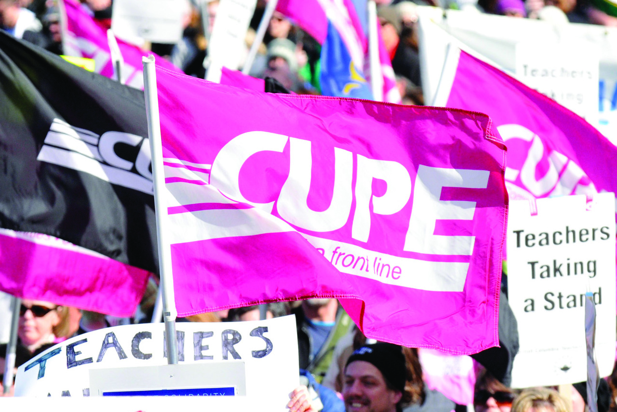

Events

Membership Meeting

Tuesday, January 22, 2013 | 6:30-9:00 p.m. Legion hall, 937 Legion St.

Rally for Rights and Democracy

Saturday, January 26, 2013 | 1:00 p.m. Legislative building

Annual General Meeting

Tuesday, April 2, 2013 | 9:00 a.m.Downtown City hotel, 123 Hotel St.

Day of Mourning for Workers Killed and Injured on the Job

Sunday, April 28, 2013 | Details TBD

Annual Local BBQ

Saturday, June 1, 2013 | Details TBD

Check out **localwebsite.ca** for more details

3 The Newsletter



Contract Language Explained

Without a union, you might start with just two weeks of vacation. Our collective agreement (CA) starts new hires with three weeks and provides more days as we gain seniority—up to six weeks per year, plus bonus days after 10, 15 and 20 year anniversary years.

And don't forget, the break between Christmas Eve and New Year’s was negotiated by your union on your behalf! We also have a provision for carrying over up to 10 vacation days into to the next calendar year.

Some members have asked, “What happens if I have more than 10 days to carry over? Do I lose the extra days?” The answer is NO! You cannot lose your vacation days.

Here’s why: Clauses 20.02 and 20.03 of the CA dictate that we are to be informed of our vacation entitlement each February, that vacation schedules shall be determined by mutual agreement and seniority, that we will be informed in October of any unused vacation, and that there is a process and a form to carry over any remaining vacation days.

These clauses put the onus on the employer to ensure our vacations are being scheduled, and that carry-over forms are submitted.

Here’s another important point: The CA does not say vacation may be carried over, it says “the remaining entitlement will be carried over to the following year.” And then it goes on to say, “With mutual agreement, such vacation entitlement may be converted to additional pay.”

But nowhere does it say you lose unused days.

We negotiated vacation because vacation is important to our health, our families, and our ability to do our jobs effectively. But workload and resources being what they are, sometimes things come up. Our managers are busy and over-worked too, so sometimes details can be overlooked. That said, if for any reason you have more than the allotted 10 days to carry over or if you believe you’ve lost out on any vacation, whether it’s because of too much carry-over time, or failing to submit the carry-over form, contact the union office or a union steward.

They will ensure you receive your full vacation allotment, either as carry-over or as a cash payout. 

[Approximate word count = 400]

Vacation: It’s Yours to Use

Tips for New and Young Workers

Courtesy The Canary, CUPE’s health and safety newsletter

All workers face a higher risk of injury in the first six months of a job, as they may be unaware of existing or potential risks. In just two years (2007-09), 124 workers between the ages of 15 and 24 years died from work-related injuries in Canada.1

Questions to Ask Your New Employer

To start things off on the right foot, ask your new employer to give you a health and safety orientation to your worksite. Here are some questions to ask:

1. What are the hazards of my job?
2. What training will I receive?
3. Is there safety equipment I’ll be expected to wear?
4. What do I do if I get hurt?
5. Who do I go to with safety concerns?

Is your workplace unsafe?

Though it is the primary responsibility of your employer to provide a healthy and safe workplace, we must not be complacent. Here are some signs that your workplace may be unsafe:

* Other workers are being injured on the job.
* You’re working without direct supervision.
* You haven’t been trained properly.
* Equipment is unguarded and/or broken.
* Containers of chemicals aren’t labeled.
* Safety shortcuts are used to save time or money.
* Poor housekeeping and maintenance (like slippery floors, frayed electrical cords) are present and not fixed when reported.

Ways to Protect Yourself at Work

* Learn about your rights and obligations under the applicable legislation in your jurisdiction.
* Take advantage of the training you are given, learn to do the job safely, and don’t perform tasks or use equipment that you have not been trained to use.
* Think the job through; know what to do when there is an injury or emergency.
* Get help, especially if you have to lift something heavy or are not sure how to do a task that may be dangerous.
* Wear the safety gear that is required to do your job safely.
* Tell your supervisor if you see any hazards or violations.
* Talk to your coworkers, friends and even your family about your job; they might know something you don’t!

Other job-related factors include lack of training and supervision, unsafe equipment, stressful conditions and working too quickly. 

Want to know more? Check out   
the full, downloadable fact sheet   
at **cupe.ca/health-and-safety/  
new-workers**

1Association of Workers’ Compensation Boards of Canada http://awcbc.org/en/youngworkerresourcesinformation.asp

Health & Safety Tips

4 The Newsletter

