Women leading change through
member engagement

Guide to mapping your workplace

Table of contents
What is mapping? 2
Type of information to include in a map 3
Types of maps 4
1) Flowchart map 4
2) Blueprint map 6
3) Spreadsheet map 7
Mapping checklist 9

What is mapping?
Mapping is an organizational tool that creates a visual representation of a specific workplace or series of workplaces. It’s one of the most effective ways of examining how your members connect with each other and with the union.

Every workplace has a formal organization (locations, departments, shifts) organized by the employer and an informal or natural organization, created by workers.

Mapping can be done in different ways and for different reasons. The most basic reason why we do it is because it has been demonstrated to be the most effective way to visualize and assess where we have support, where we don’t, and where we can create inroads and build alliances.

It helps us to reach every worker in the workplace and bring various work groups, social groups, and organic leaders to light. Workplace maps will help you to identify key areas that require attention in order to build a stronger and more cohesive local.

Mapping also provides opportunities to get members involved in building local capacity – providing a sense of shared ownership and responsibility.

The process and the product at the end are both useful in developing the organizing team and the knowledge base for the campaign or drive. Mapping your workplace will enable your local to develop a coordinated strategy rather than organizing and recruiting on an ad-hoc basis.

Mapping should always be done in a group as no one person holds all the answers. Maps are also never completed in one single round, so don’t get discouraged if it takes some time to map your workplace.

Type of information to include in a map
- Department, work area, or site.
- Job classification.
- Job status (ex: casual, temporary, seasonal, part-time, full-time).
- Shift (ex: day, night, etc.).
- Union membership status.
- Gender expression.
- Age.
- Equity-seeking?
- Language(s).
- Position or previous position with the local.
- Community groups associated with.
- Political affiliation.
- Geographic location.
- Other unions / associations in the workplace.
- Seniority.
- Family/friends within workplace.
- Other connections.
- Are there particular workplace concerns?
- Carpool?
- Smokers?
- Active on social media?
- How does news travel?
- Family status/kids?
- Social activities among co-workers?
- What are the social groups at work?
- Where do people gather?

Types of maps

1) Flowchart map

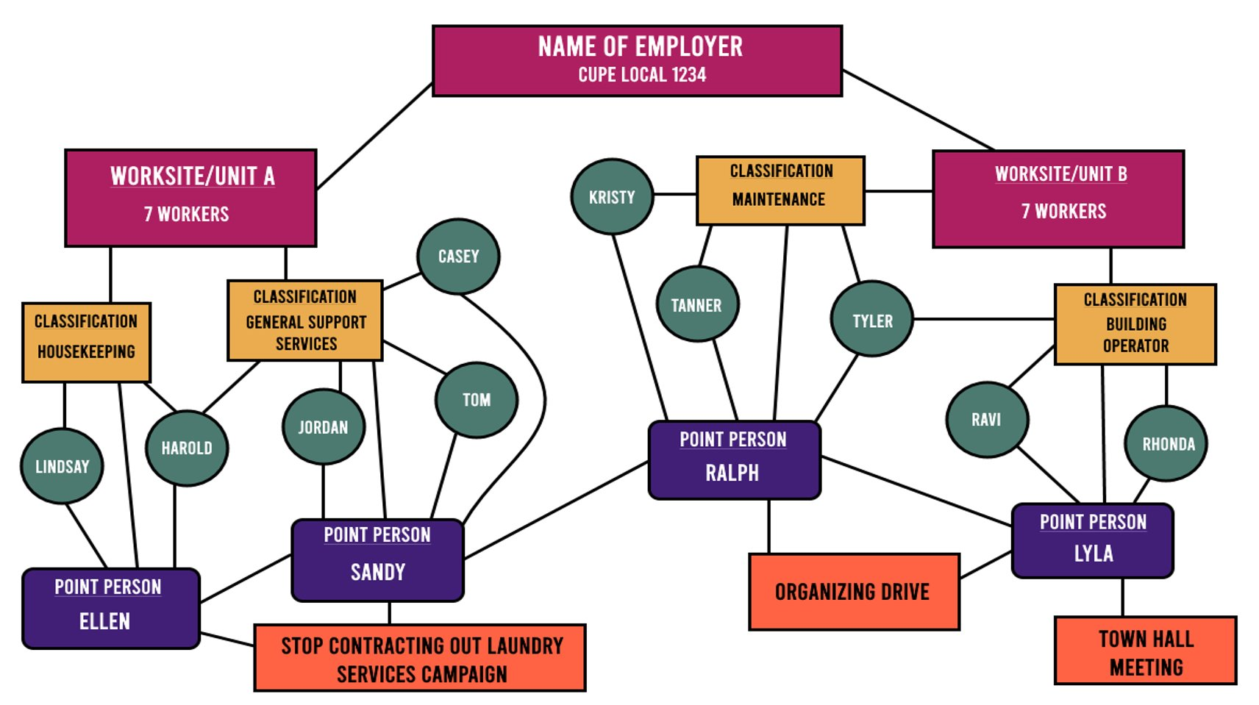

Flowchart maps are a quick and easy way produce a map of your workplace that represents each worker, their relationship to each other, and to the organization. There is no right or wrong way to start a flowchart map.

In this example, we are dealing with a small workplace of 14 unionized employees.

At the top you find the name of the employer and the local number. This then breaks off into two subheadings that represent the two work areas of this workplace.

From there, we see that each unit is broken into the classifications of workers contained within the unit – in this example, there are 4 different classifications of workers: housekeeping, general support services, maintenance, and building operators.

If you choose to use a flowchart map, it can be helpful to include as much information as possible, so if there are some non-union employees in that unit, you should also include their classification(s) and information on your flowchart.

Then we see the actual workers represented in green circles. In some instances, a worker may work in two different classifications. Make sure to connect them to both like we’ve connected Harold and Tyler in the example.

In this example, this local has four point-people (aka organizers) that are connected to each unit, employee, and to each other. Having an organizer from each classification and each work unit not only helps you build your map faster, but it provides you with a direct link to each working group so that you can create a more accurate map. These organizers are likely people who would have helped create this flowchart map.

Finally, you’ll notice that each of the point-people are connected to another item. These items represent campaigns, projects, or events that the local is working on. Including these items in the map helps provide a clearer picture of the work your local is committed to or planning.

Another added step to this process is to include relationship links or personal connections. This chart uses green lines to represent positive relationships and red lines represent negative relationships or people who don’t necessarily always see eye-to-eye. Adding these relationship links will help you to understand the inner relationships and dynamics at play in your workplace.

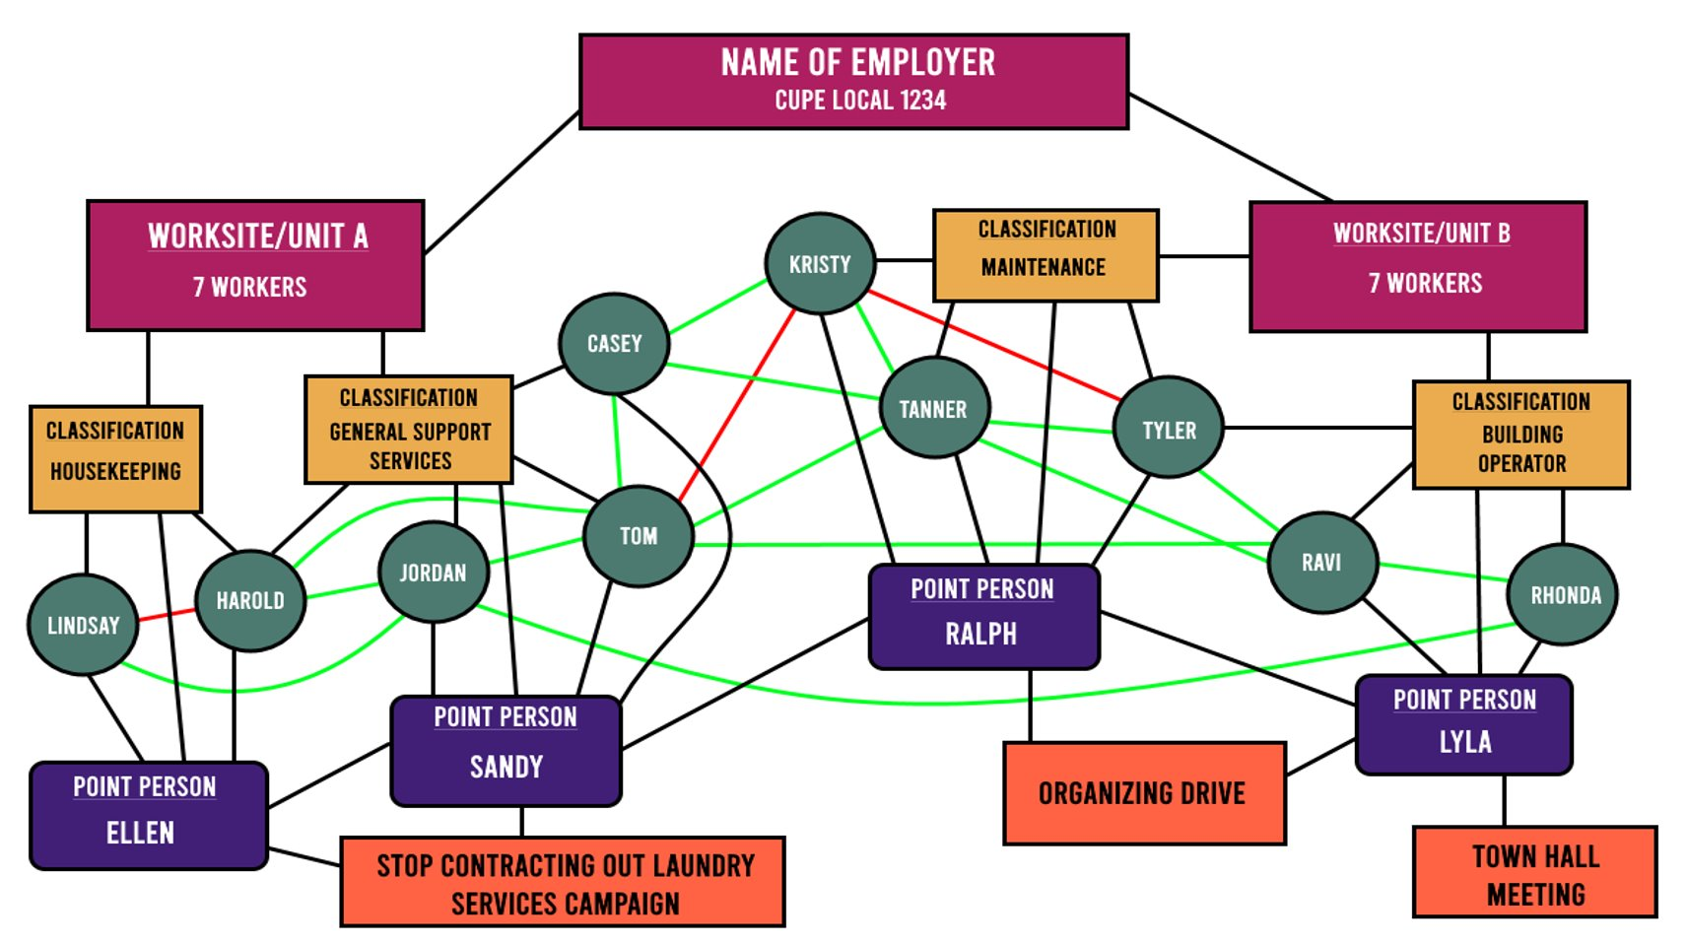

Limitations of flowchart maps:
- It would be difficult to represent large workplaces.
- Takes up a lot of space.
- Can get messy and complicated.
- Could be difficult to add or change information.

2) Blueprint map

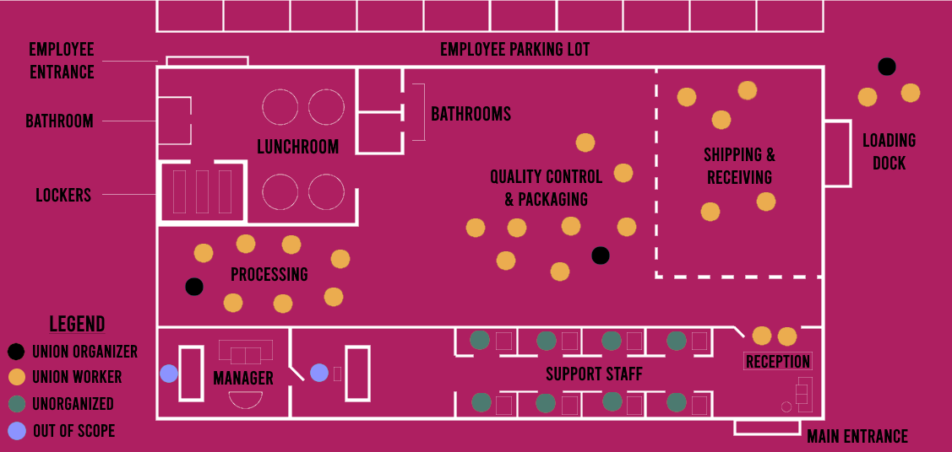
A blueprint map is exactly what it sounds like. Blueprint maps create a literal depiction of your workplace that show you where the workers are and what (if any) obstacles are in the way of reaching them.

This example shows you what a base map could look like. As you can see, it helps you to easily identify where gathering spots might be, where most of your members are, and which workers may be isolated from the rest of the workforce. Once you have created your blueprint, you can begin to add more information.

While this example is fairly basic, blueprint maps can include a wide variety of information from shift schedules and break times to arrows that represent the general flow of “traffic” through the workplace.

A helpful tip is to include a legend to keep all your symbols organized.

Limitations of blueprint maps:
- Information is generally depicted through symbols which could get confusing.
- Harder to identify specific individuals.
- Harder to demonstrate relationship links between workers.

3) Spreadsheet map

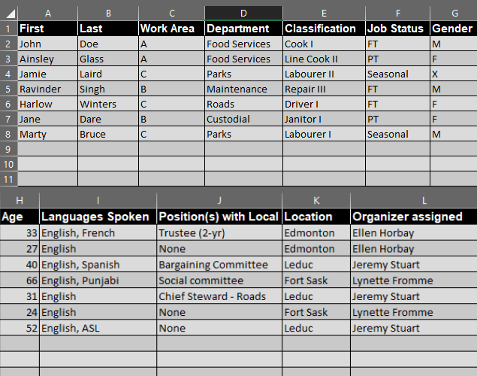

Spreadsheet maps, while comprehensive, aren’t as fun to look at as a flowchart map or a blueprint map. That said, spreadsheet maps are a way to capture lots of information while having the ability to easily add, edit, or remove information with the click of a button.

These kinds of maps do not provide a visual depiction of the workplace in the same way that flowchart and blueprint maps do, however they can contain any and all information that your local deems important.

Limitations of spreadsheet maps:
- There is no visual representation, only data.
- Spreadsheets can be complicated to read and maneuver.
- Potential for multiple versions of the spreadsheet resulting in people looking at outdated versions.

Each type of map has its limitations. It can be helpful to use a combination of two or more types of maps – you don’t have to just pick one! For example, using a blueprint map and a spreadsheet map will allow you to create a large visual representation of your workforce with a group of people while you maintain day-to-day information tracking in a spreadsheet map.

Mapping checklist
This checklist is a helpful tool to use prior to beginning to map your workplace. It is not an exhaustive list – the more information you can include in your map, the better!

- Who manages the facility?
- Who owns the facility?
- What is the legal name of the organization?
- What departments are there?
- How many classifications of employees are there and what are they?
- Is there more than one union at the worksite?
- Are there non-union workers at the worksite?
- How many workers are:
  - Full-time?
  - Part-Time?
  - Casual?
  - Seasonal?
  - Temporary/Term?
  - Men?
  - Women?
  - Non-binary/Other?
  - 2SLGBTQI+ identified?
  - Workers of colour?
  - Métis, Inuit, or First Nations?
- Where are your members located geographically? (ex: are they spread across a region or several cities?)
- How many workers are members in good standing of your local?
- What are the ages of your members?
- What are the levels of seniority across the union?
- Are there any family members that work together?
- What is the family status of your members?
- Who holds positions in the union?
- What are the predominate languages spoken in the workplace?
- What are the hours of operation?
- What are the shift schedules?
- Do employees have a separate entrance?
- Do employees have a break/lunchroom?
- Do workers hang out somewhere after work?
- Do we have names/personal contact information of workers in any of the areas or departments?
- Do we have names/contact information of any supervisors in any of the areas or departments?
- Do employees have a separate parking lot?
- Is there an area where workers take breaks?
- How do people get to work?
- Are there areas where you can access information about employees? (example: employee intranet, workplace newsletter, etc.)
- Do you know about any incidents of harassment or discrimination?
- Are there any health and safety hazards in the workplace that the employer needs to address?
- What are the major workplace concerns?
- Who are the identified leaders in your workplace?
- Is overtime mandatory?
- Is overtime allocated fairly?
- Does everyone receive the same benefits at work?

:rdt/COPE491 2023-03-02

