You’ve been elected to your local:

now what?

Resource guide for inclusive meetings

Why this resource?
As leaders, it is our job to make meetings as welcoming and inclusive as possible for people who might want to be involved. This resource contains a few tools for making meetings more participatory. When we include more perspectives in our decisions, we are more likely to have a union that meets the diverse and changing needs of our broader membership.

Use these tools to hear more perspectives and make more informed decisions. Try them with your committees to take a broader cross section of members’ experiences and points of view into account in your planning. These are just few examples of ways to include a broad cross section of members with diverse experiences that will help us build power in our unions.

How to use it:
- Use the Table of Contents on the next page.
- Start with the objective. What do you hope to achieve in this conversation?
- Pick an approach that you feel you can facilitate.
- Get consent from your group to give it a try.
- Plan to have a quick debrief about the process: What did you notice? What worked well? What didn’t? How might this tool be useful in the future?

What else?
Talk to your education representative about workshops and other resources for:
- Strengthening your team and resolving conflict.
- Making meetings and decisions more inclusive.
- Increasing member engagement.

Table of contents
Objective | Tools | Page
Hear everyone’s ideas | Go around | 4
 | Small groups | 5
 | World Café | 6
 | Parking Lot | 7
 | Brainstorm | 8
Analyze a situation together | SWOT Analysis | 9
 | Problem Tree | 10
 | Affinity Diagram | 11
Make a decision/ Prioritize | Consensus decision-making | 12
 | Weighted Vote | 14

Hear everyone’s ideas

Go-Around
Why use it?
- Hear everyone’s ideas and opinions on a subject.
- Hear what assumptions, beliefs or ideas people are arriving with.
- Pause and reflect, to reorient a discussion when there is tension or many different points of view.
- Allows people to express themselves calmly without fear of being interrupted.
- Makes people aware of interrupting others and helps break the habit.

How it’s done:
- A go around is best done in a circle or some seating arrangement where everyone can see each other.
- Anyone can volunteer to go first.
- Go to the left in sequence.
- Only the person whose turn it is, is permitted to speak. You can set a time limit per speaker to ensure the space is shared equally.
- Anyone can pass if they are not ready.
- Come back to them to see if they want to contribute once the go around is done.

Small Groups
Why use it?
Hear everyone’s ideas.

Large group discussions run the risk of being dominated by a few people or one way of thinking about a situation. They can limit creativity and participation.

When discussing complex topics, it is helpful to think about them in a broad way before we narrow down our thinking about what action we will take. In a large group, discussing broad, general questions can be unproductive.

Smaller groups allow time for everyone to speak and to feel involved and can be less intimidating. New ideas emerge in small group discussions more easily. And everyone feels included. It is easier to discuss emotional issues in small groups.

Small group discussions are an efficient way to explore an issue and get to solutions. You can cover several different topics at once – with each group taking on one topic or task.

How it’s done:
- Be clear about the topic for discussion. A clear question that is open-ended, or a specific task can be helpful.
- Plan for the “harvest:” What kind of information do you want to come out during the debrief or report back?
- Leaders do not need to know everything that was said in a small group discussion. Often, it’s more useful to draw out highlights and key ideas.

Here are some ideas for reporting methods:
- Round-robin: take an idea from one group, a different idea from the next group and continue the round until all ideas have been shared.
- Prioritizing: each group chooses its most important idea and reports back on it.
- Arranging and categorizing: groups arrange their ideas (for example: cards indicating steps in a sequence) or gathers them in categories (for example: sticky notes on the wall).
- Open discussion: A whole groups discussion will benefit from some initial thinking having been done in small groups.
- Short group reports: by an individual from each group.

World Café
Why use it?
World Café got its name because it imitates a café setting where small groups (4 or 5 people) are conversing together around tables.

It is an ideal way to find out what a group is thinking and feeling about a topic.

How it is done
- After the first conversation, someone stays at the table as “host,” while the others move to a new table, taking their previous conversations with them. This way all participants have an idea of the conversations taking place.
- The host begins with a warm welcome and an introduction to the World Café process, setting the context, sharing the Café Etiquette, and putting participants at ease.
- 3 Small Group Rounds:
- Round One: a small group sits around a table. They discuss a broad question. At the end of the round, each member of the group moves to a different new table, except for the “Table host.” The “Table Host” is a volunteer who remains at the table for the duration of the Café; they welcome the next group and briefly explain what happened in the previous round.
- Round Two: the newly formed group discusses another question that helps focus their thinking on the challenge at hand. At the end, the host stays and explains to the next group briefly what happened in the previous round.
- Round Three: The newly formed group discusses a question that will lead to the outcome or harvest that will move the work forward.
Note: The same questions can be used for more than one round, or they can be built upon each other to focus the conversation or guide its direction.

- Harvest: After the small groups, individuals are invited to share insights or other results from their conversations with the rest of the large group (“best ideas” or “three key findings”). As the groups report, the ideas/findings are put together to highlight patterns that are emerging.

Parking Lot
Why use it?
- Hear everyone’s ideas.
- Using a parking lot ensures that all ideas get recorded and participants don't feel like they've been ignored.
- You can capture people’s points or concerned without getting off topic, by “parking them” for later.
- Sometimes it is called a bike rack or refrigerator (keeping good ideas “on ice” for later).
- This allows you to stay focussed but reassures participants they will be heard.
- Whenever anything comes up that's not relevant to the discussion at hand, or that requires more thinking before it can be addressed, “park” it in the parking space (often a sheet of flipchart paper on the wall).
- Of course, make sure you do deal with parked items!
- Consider having a space reserved on the meeting agenda to deal with parked items.

Brainstorm
Why use it?
There are many tools to help us expand our thinking about an issue, before narrowing down to choose an action. The purpose of a brainstorm is to imagine as wide a range of possibilities as possible, before narrowing down what a group will focus on.

A brainstorm allows us to dream big and imagine many possible outcomes without being limited by concerns about resources and capacity. This helps us raise expectations and increases confidence and builds hope.

In the process, new ideas tend to emerge that ARE possible. But that we might now have otherwise considered.

What is a brainstorm?

In a brainstorm, there are no bad ideas. There is no assessment of the ideas at all until the brainstorm is done.

How it’s done:
- One person writes to capture the ideas that come up.
- Another facilitates to ensure everyone is heard.
- Go around the room as many times as you can or need to until there are no further ideas. Be patient as sometimes ideas pop up in quiet.
- This person, often the chairperson, has the challenging task of preventing the group from moving into debate before the brainstorm is done.
- Once all ideas have been captured, review what has come up. Reflect before you reject any of them. Then choose a decision-making method to prioritize and choose what you will focus on next. Often the choice of the group will be obvious through the process.

Analyze a situation together

SWOT Analysis
Why use it?
- Analyze a situation together.
- What is SWOT? It’s Strengths, Weaknesses, Opportunity, and Threats.

How it’s done:
- Divide a sheet of flipchart paper into four quadrants. Label the two top quadrants Strengths and Weaknesses (current situation), and the two bottom quadrants Opportunities and Threats (future considerations).
- Lead a brainstorming session for each quadrant.
- Make a list of ideas generated for each of the quadrants.
- You can either take the quadrants in order, or you can allow an idea from one quadrant will give rise to another in a different quadrant. This is an example of the phenomenon of yin and yang: for example, an opportunity can be seen as the flipside of a weakness.

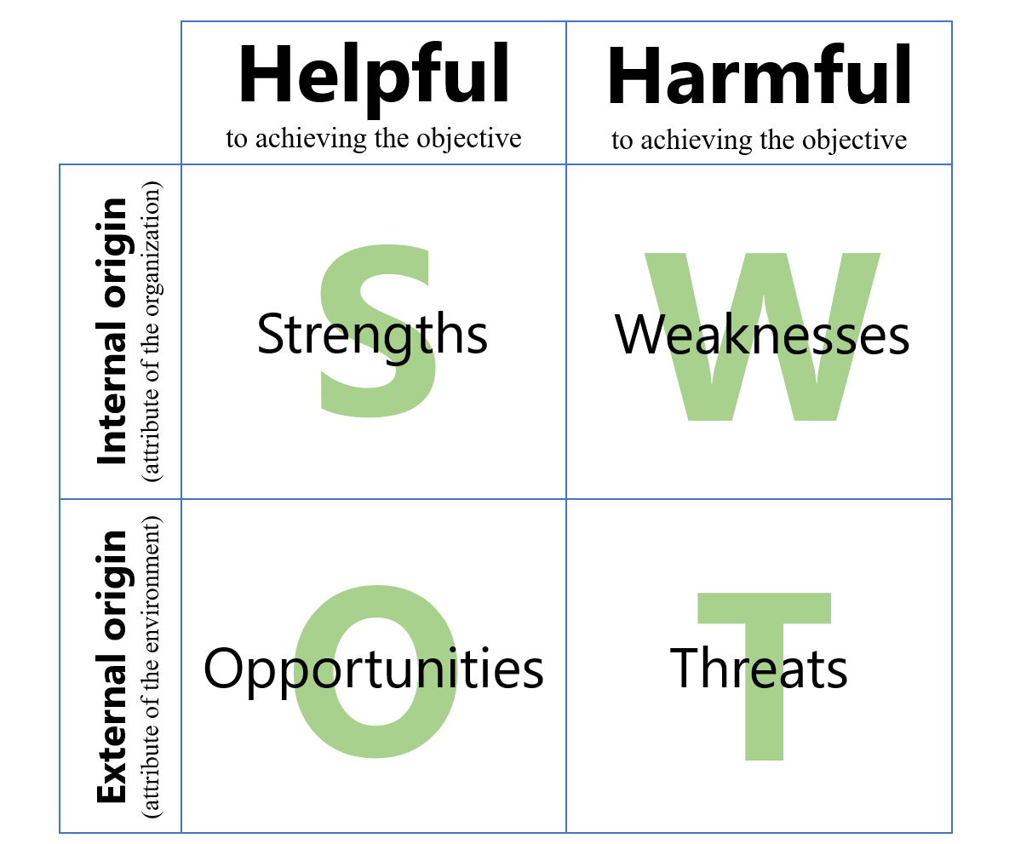

Problem tree
Why use it?
- Analyze a situation together.
- The purpose of this exercise is to analyze the stated problem and its origins in terms of cause-and-effect relationships.

How it’s done:
- This is a three-part process:
  - State the central problem clearly and precisely. This will be the bottom of the tree trunk.
  - Determine its primary and secondary causes (the roots of the problem).
  - Describe the problem’s consequences, both immediate (the branches) and secondary (leaves).
- Completing a problem tree is a time-consuming exercise. For greater effectiveness, do this exercise in a large enough group. Don’t hesitate to split the problem up into multiple levels.

Affinity Diagram
Why use it?
- Analyze a situation together.

How it is done
- Begin by clearly explaining the issue being discussed.
- Ask participants to spend five minutes thinking about this issue and to do their own individual brainstorm, silently, of their ideas on the subject. Get them to write each of their ideas onto a post-it note. They should use a new post-it for each idea.
- Once everyone has finished, invite them to post their notes anywhere on the wall. Then, ask the whole group to move the notes around, collecting related ideas together. This should be done by all participants at the same time, without talking.
- The sorting process will slow down or stop once everyone is comfortable enough with the groups of ideas. It’s all right for certain ideas to remain alone.
- For each group of ideas, ask participants to suggest a suitable title or headline. These headlines are the key questions to be discussed by the group and can also form the starting point of an action plan.

Make a decision/prioritize

Consensus decision-making
Why use it?
- Make a decision together.

How it is done:
Introduce the item needing a decision:
- Define it.
- State what is to be decided.
- Provide or solicit background information.

Discuss:
- Build on one another’s ideas.
- Everyone contributes, even if it is just to agree with a point or ask for clarification.
- This step should take most of the process time – the more all the diverse points of view have been brought out and understood, the more likely that the proposal that someone will suggest will meet the needs of everyone.
- Facilitator/chair keeps the discussion on track, clarifies, and periodically summarizes.

Propose:
- At some point, someone will make a proposal to address the issue OR if the discussion is becoming repetitive, the facilitator/chair states the conclusion that seems to be emerging.
- The proposal does not need to be perfect – but it needs to be something that everyone can live with.

Test for consensus:
- Do a round – silence can only be taken to mean agreement if that is stated as a ground rule.
- The test is “Can I live with this?”
- If a person blocks the proposal, they have an obligation to make another proposal. Facilitator/chair re-states the proposal and tests for consensus.
- If consensus cannot be reached within the allotted time, an agreed-upon alternative should be adopted.

Confirm:
- State the decision.

Weighted Vote/Dotmocracy
Why use it?
- Make a decision together.
- One advantage of this approach is that all options remain present. Even if they are not selected as the top choice.
- You will get information about other priorities in addition to the one that you land on as a group.

How it is done:
- Collect all the ideas you have or options available.
- This can be done using a brainstorm, world café or small group discussion with a focused question to generate ideas that you collect and post.
- Before you go to the weighted voting, allow space for any other ideas that should be added for consideration.
- To gauge the relative importance of different options, ask participants to vote using round coloured stickers or felt-pen checkmarks for their first choices.
- Each participant rates their choices, instead of ranking them, by assigning them relative values.
- For example, each participant has six points (votes) to distribute among the options. Points can be allocated to as many or as few options as they like: all six to their preferred choice, or three to the first choice, two to the second and one to the third.

:rdt/COPE491 2023-03-02

