2014 Black History Month Event
A Celebration and Contemplation

CUPE Nova Scotia Celebrates Black History Month by hosting a discussion with Captain Kevin Reade, one of the leaders of the Halifax Black Firefigthers Association’s recent and historic, successful Human Rights challenge.

Dignitaries from Halifax’s African-Nova Scotian community including Halifax Regional School Board Member Melinda Daye, Dr. Rhonda Britton, former NDP MLA Percy Paris, and our Poet Laureate El Jones will be joining us for what we hope will be a lively discussion on Restorative Justice practices and the struggle for equality in our workplaces.

When: Saturday, February 22, 2014
11 am to 2 pm

Where: Cornwallis Street Baptist Church, 5457 Cornwallis Street, Halifax
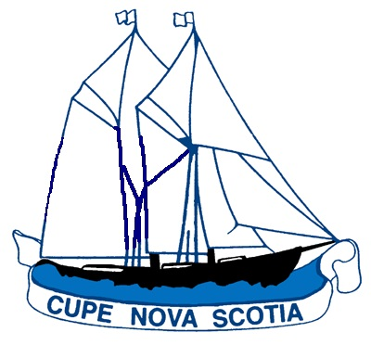
Light refreshments will follow!

cope 491

