Report on the Utilization of Licensed Practical Nurses
In Saskatchewan

Results of a survey of LPNs in five health regions and case studies of five workplaces



CUPE Research
September 2003

Table of Contents

Executive Summary 1
Introduction 5
Survey Results 7
Development of questionnaire 7
Response rate 7
Our sample 7
Years working as an LPN 8
Sector or primary workplace 9
Urban/rural split 10
Administration of medications course 10
Utilization of skills 11
How LPNs are affected when skills not utilized 13
Skills that LPNs are allowed to perform 16
Administration of medications 18
Who decides which tasks an LPN can perform? 19
Reasons for not using LPNs to full scope of practice 19
Promoting LPN utilization 20
Case Studies 21
CASE STUDY #1 21
Family Medicine – Unit 4A, Pasqua Hospital, Regina 21
CASE STUDY #2 25
Victoria Hospital, Prince Albert 25
CASE STUDY #3 29
Radville Marian Health Centre, Radville 29
CASE STUDY #4 32
River Heights Lodge, North Battleford 32
CASE STUDY #5 36
Home Care, Yorkton 36
Conclusion and Recommendations 40

Executive Summary

Between April and June of 2003, the Canadian Union of Public Employees (CUPE) undertook a study to examine how well Licensed Practical Nurses (LPNs) were being utilized by health care employers in five health regions in the province. We focused on the health regions of Prince Albert Parkland, Sunrise, Sun Country, Regina Qu’Appelle and Prairie North where CUPE represents LPNs and other health care providers.

The research took two forms: firstly, a survey of LPNs in the five health regions to determine how well their skills were being used; and, secondly, case studies of five workplaces where LPNs are being used to their full scope of practice.

Sixty percent of LPNs are underutilized

Our survey was sent by direct mail to 890 LPNs in the province and we had an excellent return rate of 43.4%. The results of our survey confirmed our concerns about the underutilization of LPNs in the workplace. About 60% of LPNs reported that their skills are not being fully used (32% said their employer does not use their skills and 28% said their skills are used sometimes). Only 40% of LPNs said that their employer fully utilizes their skills.

PA/Parkland has the highest utilization of LPNs

The survey also revealed that there are great differences among the health regions in the way they use LPN skills. For example, LPNs in the Prince Albert Parkland Regional Health Authority reported the highest levels of skill utilization: 65.5% said that their employer fully utilized their skills, 27.3% said their skills were used sometimes and only 7.3% said their skills were not used. By comparison, only 21.6% of LPNs in the Sun Country Regional Health Authority said their employer fully utilized their skills, 43.2% said their skills were used sometimes and over one-third (35.1%) said that their skills were not used.

The higher utilization of LPN skills in the PA/Parkland region is a reflection of the recent move of the main acute care facility in the region, Victoria Hospital, to a health care model that uses LPNs to their full scope of practice. We have highlighted Victoria Hospital in our case studies in section two of our report.

LPNs in long-term care are more likely to be fully utilized

The utilization of LPN skills also varies among the sectors of health care. Long-term care has, by far, the highest use of LPN skills. Just over 69% of LPNs working in long term care reported that employers fully utilized their skills compared to only 42.5% of LPNs in integrated facilities and 40.6% of LPNs in acute care. Sixty percent of LPNs in home care said they were fully utilized.

LPNs experience frustration and stress when their skills aren’t used

Almost 90% of LPNs (88.8%) reported feeling frustrated when they could not use their skills. Almost 80% said they feel stress, 76.2% experience a lack of confidence, 73.2% don’t feel part of the team, and about 65% feel demoralized when their skills aren’t used in the workplace.

In Sun Country Regional Health Authority where LPNs reported having the lowest utilization of skills, almost three times (64.3%) as many LPNs said they frequently feel frustrated compared to only 22.7% of the LPNs in the PA/Parkland Regional Health Authority. This shows a link between the low utilization of skills and employee morale and health. When LPNs are not allowed to use all of their skills in the workplace, they experience a high degree of frustration, stress, demoralization and lack of confidence in their abilities.

LPNs not permitted to use their training and skills

Even though 91.6% of surveyed LPNs said they had completed their Administration of Medications course, only 40.9% said they were permitted to always administer medications. Provincially, 79% of all LPNs have completed the required course for administering medications. It is more likely that LPNs working in long-term care facilities will administer medications: 94% of respondents in long-term care said they are always permitted to administer medications compared to only 22.8% in acute care. In acute care, more than one-half of the LPNs said they are never allowed to administer medications.

LPNs reported low utilization of other skills in the workplace.

The person who decides tasks can impact utilization

Across the five health regions, it is most common that a nurse manager is deciding which tasks an LPN can perform in the workplace (54% of LPNs identified the nurse manager as the one who makes decisions). In acute care, 62.5% of LPNs said the nurse manager allocates tasks compared to 54.7% of LPNs in integrated facilities who identified the RN on shift who makes those decisions.

In the Sun Country Regional Health Authority, more LPNs identified the RN on shift making those decisions than did LPNs from other health regions. Almost 42% of LPNs in Sun Country said the RN on shift determined tasks compared to only 25% of LPNs in Regina Qu’Appelle or 28% of LPNs in PA/Parkland. LPNs from Sun Country also report the lowest levels of skill utilization.

Reasons for not using LPNs to full scope of practice

The most common reason for not using LPNs to full scope of practice, according to the LPNs surveyed, was hospital or administrative policy (71.1% identified this). It does not appear that employers are underutilizing LPNs because they don’t have their LPN training up to date. A very small percentage of LPNs thought that they were underutilized because LPNs needed skills upgrading (only 16.1%) or that there weren’t enough available LPNs (9.7%).

How to promote LPN utilization

When asked what changes LPNs believe are needed to allow LPNs to work to their full scope of practice, the majority (68.8%) said clear policies from the Regional Health Authority were needed, followed by 60% who felt that RNs and RPNs should be educated on LPN competencies, and 54.7% who felt managers and administrators should be educated on LPN competencies.

Case studies show that using LPNs to full scope brings many benefits

Our five case studies provide examples of workplaces that have embraced full scope of practice for LPNs and reaped the benefits as a result of the model change. In every case, LPNs and managers believe that they are providing better quality health care to their patients and residents by allowing LPNs to use the full range of their skills. LPNs overwhelmingly report a high level of job satisfaction, commitment and pride in their work. LPNs and managers also speak enthusiastically about the benefits and effectiveness of nurses working in a multidisciplinary team.

In almost all of the case studies, there was no loss of Registered Nurse (RN) positions as a result of LPNs working to their full scope of practice. At Victoria Hospital there was a loss of RN positions but this was not the result of using LPNs to full scope of practice. RN vacancies is part of the overall shortages of health care professionals in Saskatchewan that is more acute in the northern part of the province.

Health employers need to fully use the skills of LPNs

The results of our survey show that employers are still not fully utilizing the skills of Licensed Practical Nurses. The Canadian Union of Public Employees believes it is time that the provincial government, regional health authorities and health care employers make a concerted effort to use LPNs to their full scope of practice. Our case studies show the important benefits of fully utilizing LPNs: it improves our health care system by providing better quality care to patients and residents, makes our health delivery more effective, and contributes to high job satisfaction.

Introduction

Last year, the provincial government announced its Action Plan for Health Care, which will direct the shape of health reform in the province. Among the key recommendations in the report is a commitment to fully utilize the skills of all health care providers. This was a recommendation that had been strongly supported by the Canadian Union of Public Employees (CUPE) in its submission to the Fyke Commission.

Licensed Practical Nurses (LPNs) are one professional group that has continued to have its skills underutilized in health care settings. LPNs receive 14 months of training and provide nursing skills that are critical to patient care. In 2000, the provincial government amended The Licensed Practical Nurses Act to allow more independence of LPNs without the direct supervision of a Registered Nurse (RN). Despite changes in legislation and a greater awareness of LPN’s expanded scope of practice, health care employers are still not taking advantage of the tremendous skills that LPNs can offer.

This report summarizes the findings of a provincial survey of Licensed Practical Nurses represented by the Canadian Union of Public Employees in five health regions. We found that 60.1% of LPNs do not feel their skills are being fully utilized in the workplace. Only 39.9% of LPNs surveyed said that their employer uses their professional skills in the workplace.

At a time of staff shortages, extensive overtime, and increasing demands for quality patient care, it makes no sense to ignore the skills of professional staff in the health care system. Licensed Practical Nurses have important skills that can improve health care delivery and the quality of patient care.

Our report also highlights five case studies of health care employers that are utilizing LPNs to their full scope of practice. These case studies show the positive benefits of fully utilizing LPNs in the workplace, including better patient care, the development of team work, higher job satisfaction among LPNs and the expansion of health care services.

We highlight one example from each of the five health regions and from a variety of workplaces: an entire acute care facility in Prince Albert, a unit within a hospital in Regina, an integrated facility in rural Saskatchewan, a long-term care facility in North Battleford and a home care program in the Yorkton area. We recognize that these are not the only workplaces that have embraced full scope of practice for LPNs and that there may be other excellent examples. Our intention was to show a broad range of workplace settings where using LPNs to full scope of practice can and does work.

The case studies were based on interviews with nurse managers and focus groups of LPNs from the selected facilities. In some cases, such as Victoria Hospital in Prince Albert, nurse managers were dealing with difficult problems of recruitment and retention of professional staff and bed closures because of staff vacancies. Allowing LPNs to work to their full scope of practice made sense because LPNs had nursing skills that were needed so that the hospital could continue to provide high quality services to their patients.

In other cases, enthusiastic nurse managers embraced the concept of primary health care reform and wanted to include full scope LPNs as part of a nursing team. Enhancing the skills of the nursing staff in the facilities was part of a drive to improve the quality of patient care and be more effective in deploying professional skills.

There is no doubt that working to full scope of practice has been tremendously rewarding for the LPNs. In the focus groups, LPNs spoke enthusiastically about being able to finally use all their skills and apply their training. The majority had worked for years without being to use all their skills and now they have a high level of job satisfaction in their new full scope positions. They are a highly dedicated and skilled group of nurses who show a high level of compassion and caring for their patients or residents.

Health care employers need to use LPNs to their full scope of practice. The tremendous skills that LPNs have will improve the quality of health care and cannot be overlooked anymore.

Survey Results

Development of questionnaire

The survey instrument was developed in January 2003 by the research representative of CUPE and a sub-committee of LPNs from each of the five health regions represented by CUPE. A representative of the Saskatchewan Association of Licensed Practical Nurses (SALPN) also sits on that committee.

In January and February we pre-tested the questionnaire in each of the five health regions and the researcher modified the questionnaire.

SALPN assisted the project by direct mailing the questionnaires to LPNs after cross referencing their mailing list to employee lists we obtained from health care employers.

A total of 890 questionnaires with self-addressed, stamped return envelopes were mailed in the first week of April 2003. CUPE and SALPN had estimated that our union represented approximately 1,200 of the 2,100 LPNs in the province. We were unable to mail the survey to every LPN represented by CUPE but we did reach a large majority of members. We received support in data analysis from Ecotech Research.

Response rate

Of the 890 questionnaires that were mailed, 390 were completed and returned. There were 386 valid respondents, which represents a 43.4% return rate. This is a very high return rate for direct mail surveys.

Our sample

Although we did not reach every one of the 1,200 LPNs that work in the five health regions represented by CUPE, the high response rate to our survey has given us a strong sample. Our sample represents 32% of the LPN population.

Over forty percent (42.5%) of the respondents stated that they work in the Regina Qu’Appelle Health Region (RQHR). The next largest number of respondents came from the Sunrise Regional Health Authority (17.4%), followed by the Prairie North Regional Health Authority (15.5%), the Prince Albert/Parkland Health Authority (14.8%) and the Sun Country Regional Health Authority (9.8%).

The number of LPNs that responded from each health region mirrors the distribution of LPNs in each health region. As the chart below shows, the percentage of LPNs that responded to the survey is almost exactly the same as the percentage of LPNs working in each health region.

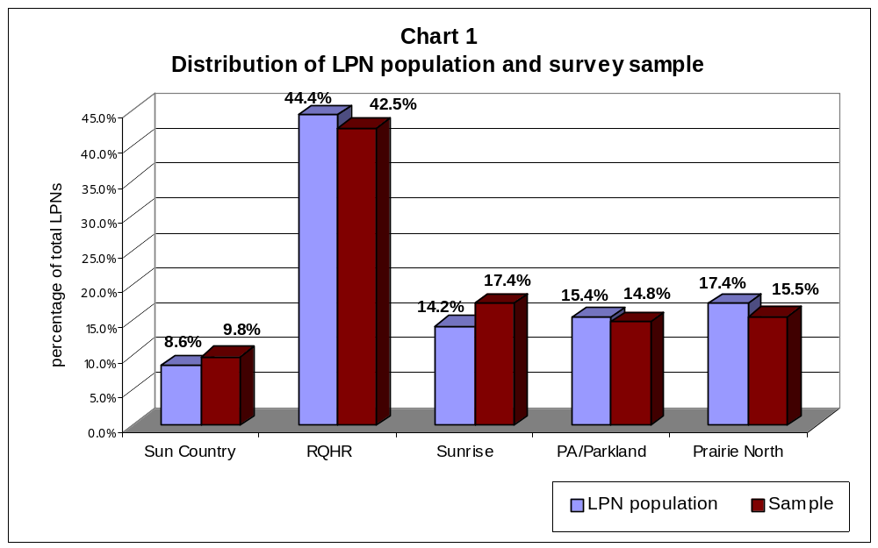

Years working as an LPN

When we look at years of service, we see that LPNs are part of an aging workforce. Almost one-quarter (24.1%) of respondents have worked less than five years as an LPN. A much higher percentage, 30.6% have worked 25 or more years as an LPN.

If we group together respondents who have worked 20 or more years as an LPN, then close to one-half fall into this category (45.1%).
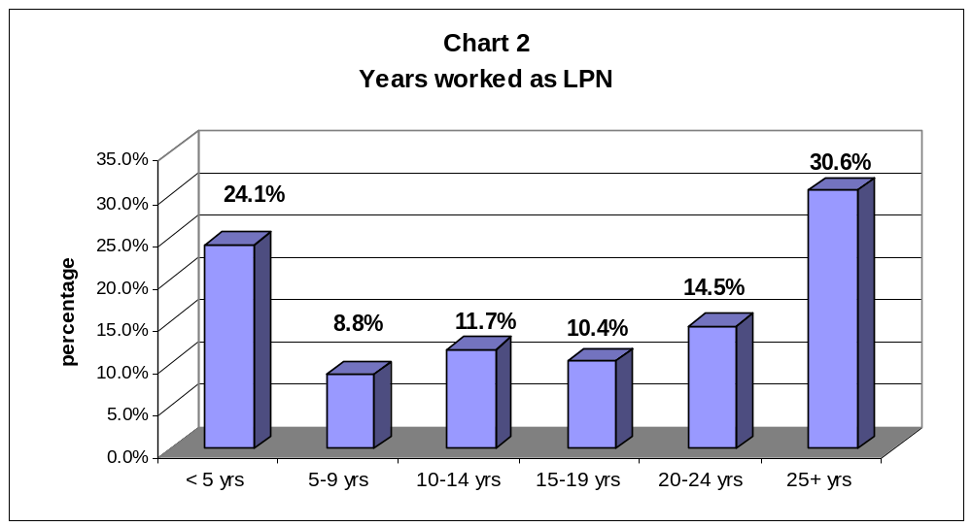

Sector or primary workplace

The majority of respondents work in acute care (58.7%). The next highest percentage of respondents (19.5%) stated that they worked in an integrated facility, and almost the same number (19%) said they worked in long term care. A small number of respondents (2.6%) work in home care. One person worked in a podiatry clinic.
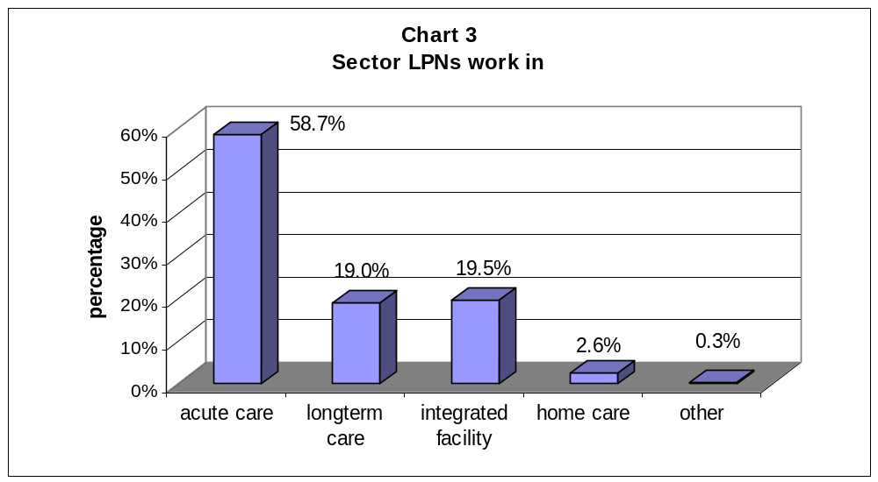

Almost one in five respondents (19.8%) said they worked at the Regina General Hospital and another 12.1% said they worked at the Pasqua Hospital. Therefore almost one-third of respondents were from just these two facilities in Regina.

Urban/rural split

By far the majority of LPNs work in a facility in an urban area, defined in the questionnaire as having a population of 5,000 or more. Almost 71% of respondents said they worked in an urban area and 28.8% said they worked in a rural area.

Administration of medications course

One of the requirements that allows an LPN to work to full scope of practice is to have completed the Administration of Medications course offered through SIAST. Since 2000, this course has been required by SALPN in order to maintain one’s license, although SALPN issues those LPNs without the course a conditional license.

A very high percentage of the respondents -- 91.6% -- said that they had completed this course. SALPN’s records show that, as of September 2003, just over 79% of all LPNs in the province have completed this course. Our survey results indicate that a higher percentage of our members have finished the course than the provincial average.

A very small number of respondents (32 respondents or 8.4% of the total) said that they had not completed this course. The most common reason respondents gave for not having completed the course was the fact that they are planning to retire or quit (17 respondents, or 45.9% of those who said they didn’t have the course). The two next common reasons were that they were in the process of or planning to take the course or they were not interested in doing medications.

Through its Employment Strategy Committee, CUPE working with the Saskatchewan Association of Health Organizations (SAHO) had provided funding to LPNs who wanted to upgrade their training to take the Administration of Medications course. Only 25 respondents said that they were not aware of the funding available to take this course.

Utilization of skills

In the questionnaire we asked a series of questions to determine if health care employers are fully utilizing the skills and training of LPNs and if not, which skills were the most underutilized.

Overall, only about 40% of respondents said that their employer fully utilizes their professional skills and training. Another 32% said that their employer does not fully use their skills and 28% said that the employer sometimes uses their skills. These results show that 60% of LPNs are being underutilized in the workplace. This is a tremendous waste of human resources and patient care skills.

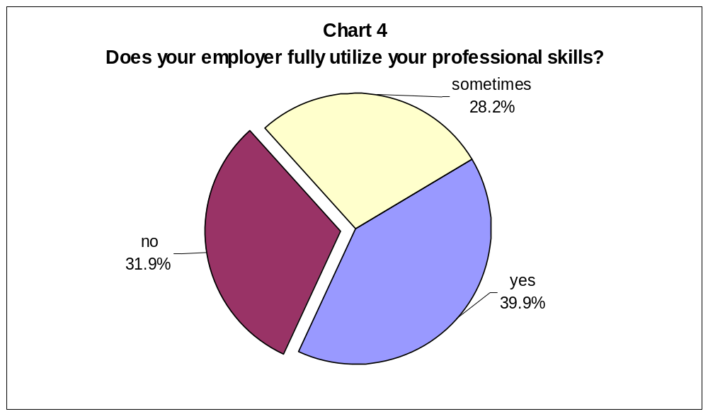

How well LPNs feel that their employer uses their skills varies significantly among health regions. In the Prince Albert/Parkland Health Region, for example, 65.5% of LPNs said that their employer fully utilizes their professional skills and a very small percentage (only 7.3%) said their skills were not used. By contrast, in the Sun Country Health Region, only 21.6% of LPNs felt that their skills were well utilized and over one-third (35.1%) said that their skills were not being used.

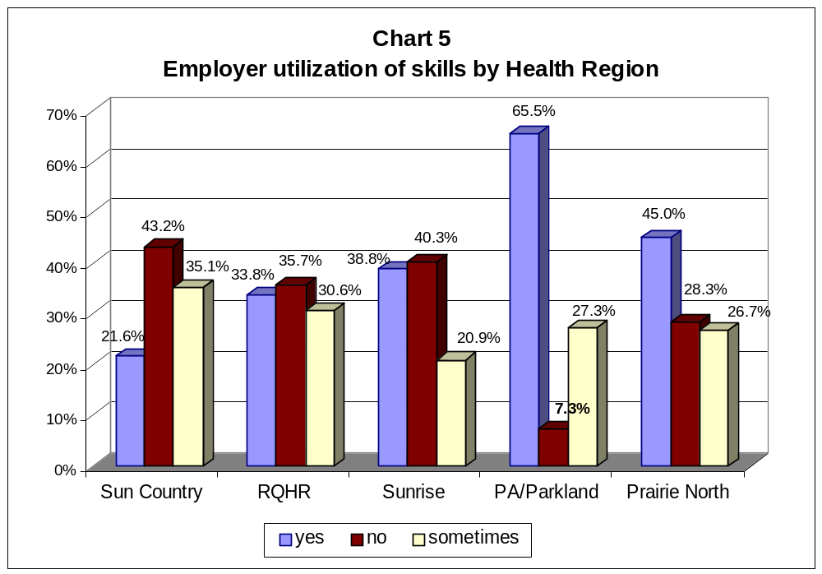

The responses to this question also varied among the different sectors of health care. The utilization of LPN skills is much higher in long term care and home care than in acute care or integrated facilities. In long-term care, 69.4% of LPNs said their employer uses their skills and only 6.9% said their skills were not used. By comparison, in acute care a higher percentage of LPNs said that their employer does not use their skills (40.6%) than those who said their employer does use their skills (33.3%).

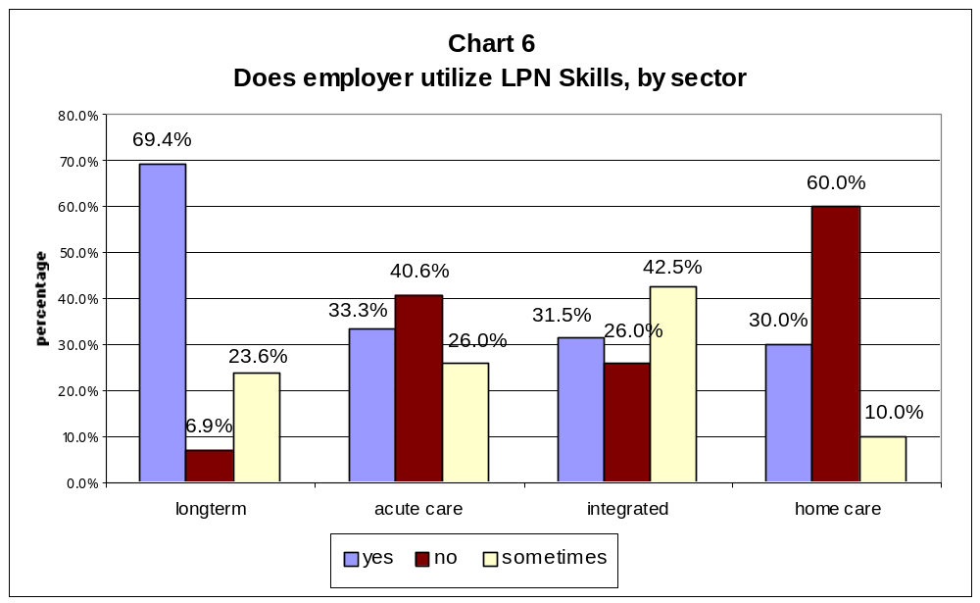

How LPNs are affected when skills not utilized

When the skills of LPNs are not being used, many LPNs experience stress, or they feel frustrated and not part of the health care team. The most common feeling expressed by LPNs in the survey was a feeling of frustration. Forty-two percent of LPNs said they “frequently” felt frustrated and another 46.8% said they felt frustrated “at times.” Together, 88.8% of LPNs said that they frequently or at times feel frustrated when they cannot use all their skills. Only 11% of LPNs said they “never” felt frustrated.

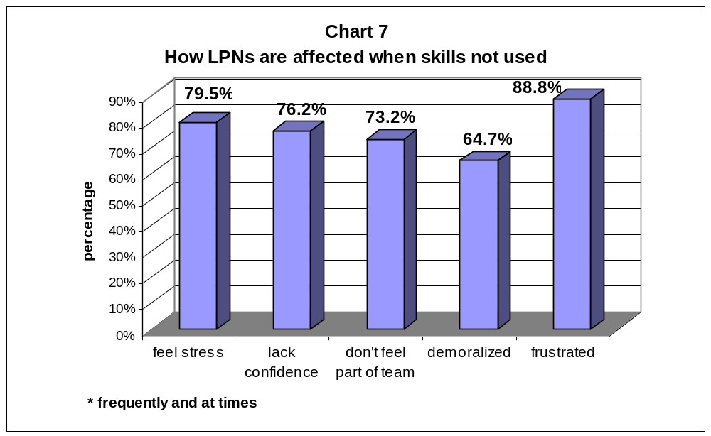

Stress was the second most common response. One-quarter of LPNs said they “frequently” felt stress when their skills were not used and another 54.5% said they feel stress “at times”. Together, almost 80% of LPNs are experiencing stress in the workplace when their skills are not used.

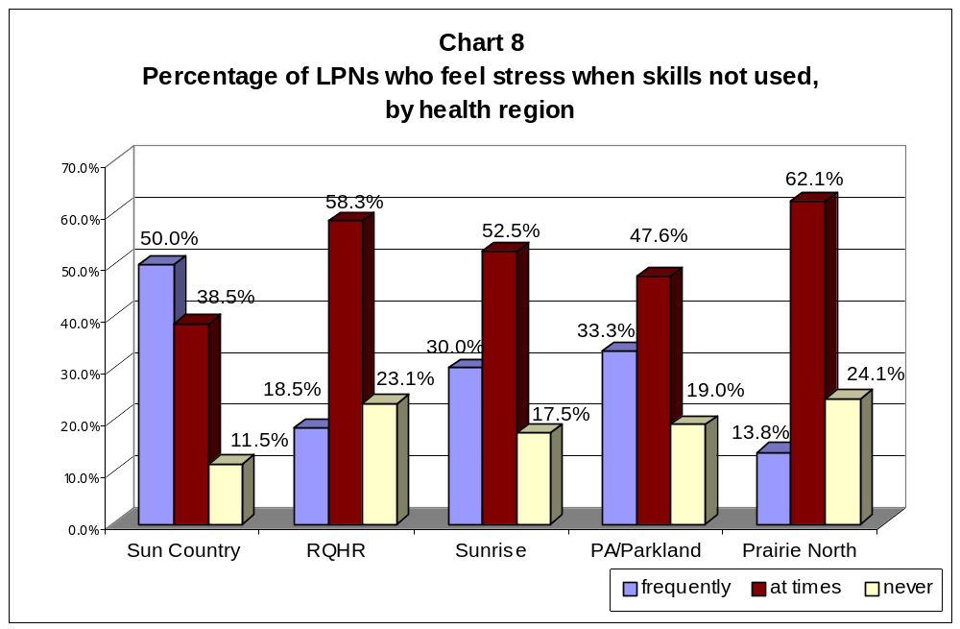

In Sun Country Health Region where LPNs reported having the lowest utilization of skills, one-half of LPNs reported that they “frequently” experience stress when not allowed to use all their skills compared to one-quarter of LPNs across the five regions.
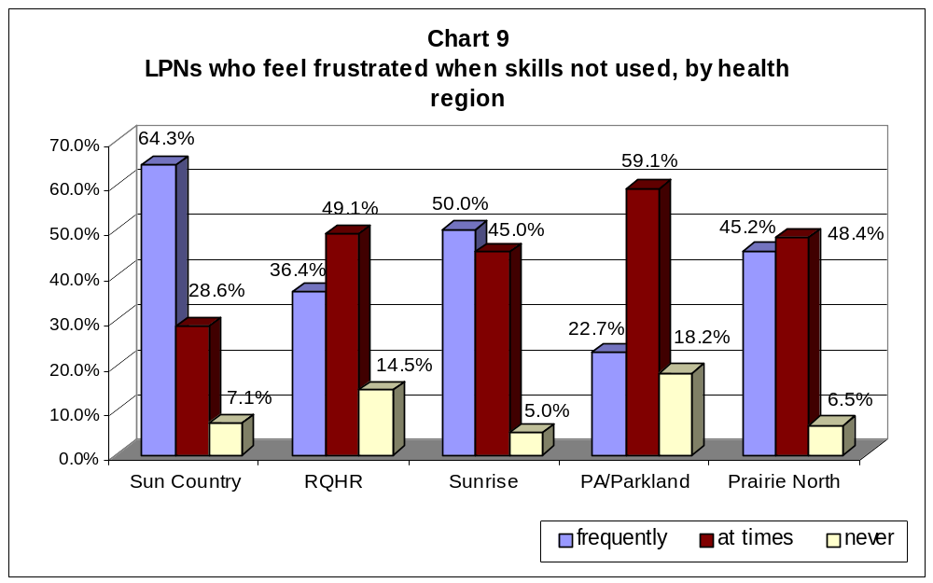

LPNs in Sun Country Health Region are twice as likely to feel demoralized than LPNs in the Prince Albert/Parkland Health Region. Thirty-six percent reported feeling “frequently” demoralized compared to only 15% of LPNs in PA/Parkland. Almost three times (64.3%) as many LPNs in Sun Country frequently feel frustrated compared to only 22.7% of LPNs in PA/Parkland. Only 7.1% of LPNs in Sun Country said that they “never” feel frustrated compared to 18.2% in PA/Parkland.

These results show a clear link between utilization of skills and employee morale and health. When LPNs are not allowed to use all of their skills in the workplace, they experience a high degree of frustration, stress, demoralization and lack of confidence.

Skills that LPNs are allowed to perform

In their training program, LPNs are taught a broad range of patient assessment and patient care skills. Through our questionnaire we wanted to determine which of the LPN competencies were the most commonly performed and which were underutilized.

We asked if they were always, at times, or never permitted to utilize these nursing skills in the workplace, or to check “not applicable” if it was a skill that normally would not be performed in their workplace.

The five most common skills that LPNs said they “always” are allowed to perform included blood glucose monitoring (88.3%), changing dressings (73.6%), patient assessments (63.6%), catheterization (62.2%), and suture removals (50.1%).

Surprisingly, only 40.9% of LPNs stated that they “always” are allowed to distribute medications, even though 91.6% of LPNs who responded to this survey said they had completed the administration of medications course. Over one-third (35.8%) of respondents said that they “never” are allowed to distribute medications.

The least common skill performed in the workplace by LPNs was carrying out doctor’s orders (processing doctor’s orders for patient care by phone or in person). More than half (52.5%) of respondents said that they “never” carry out doctor’s orders while only 20.4% said they “always” are permitted to do this.

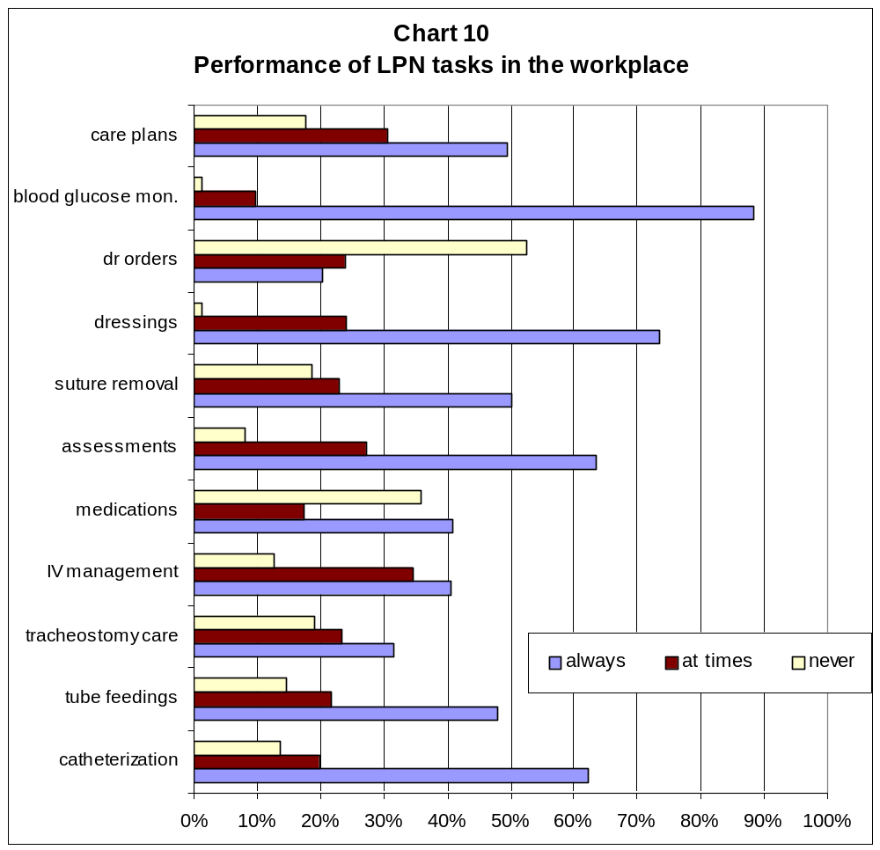

Whether an LPN is permitted to perform these tasks varies significantly between the regional health authorities and among the different health sectors. There is also tremendous variance in the utilization of LPN skills among the various health care facilities within a health region. One LPN who worked in casual positions in three different facilities in the same health region commented that she was able to work to full scope of practice in one facility and was not permitted to use any of her LPN skills in another facility.

Administration of medications

On average, 40.9% of LPNs said that they are “always” permitted to administer medications, but this task was most commonly performed in long-term care facilities. Just over 94% of respondents who work in long-term care said that they “always” are permitted to administer medications compared to only 22.8% of respondents in acute care. Only 37.5% of respondents working in integrated facilities said they “always” administer medications while 88.9% of those working in home care “always” administer medications. In acute care, 52.5% of LPNs said that they are “never” allowed to administer medications compared to the overall average of 35.8%.

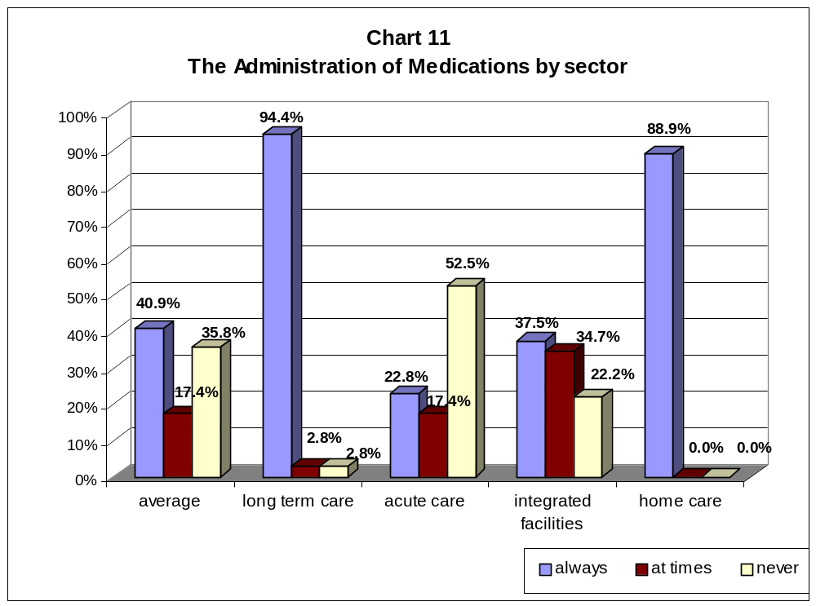

The Prince Albert/Parkland Health Region is where LPNs are most likely to administer medications: 62.5% said they “always” and only 8.9% said they “never” use this skill. LPNs in the Regina Qu’Appelle Health Region are the least likely to distribute medications. Almost one-half (47.1%) said that they “never” administer medications and 37.4% said they “always” administer medications. The low incidence in this region can be explained by the fact that the majority of LPNs who responded from that health region work in acute care where there is still strong resistance to allowing LPNs to administer medications.

Who decides which tasks an LPN can perform?

In our survey we wanted to find out who makes the decisions on which tasks LPNs perform in the workplace. Overall, it is most common that the nurse manager is making those decisions. Fifty-four percent of respondents said that the nurse manager decides, followed by administration and then the RN on shift.

In acute care, it is more likely that the nurse manager allocates tasks. Of the LPNs working in acute care, 62.5% said the nurse manager decides which tasks the LPN performs. In integrated facilities, it is more likely that the RN on shift decides what an LPN can do. 54.7% of LPNs working in integrated facilities identified the RN on shift as the person deciding which tasks they can perform.

In Sun Country Health Region, more LPNs identified the RN on shift as making those decisions than did LPNs from other health regions. Almost 42% of LPNs in Sun Country said the RN on shift allocated tasks, compared to only 25% of LPNs in Regina Qu’Appelle or 28% of LPNs in PA/Parkland. This is interesting to note because the LPNs from Sun Country also report the lowest levels of skill utilization.

Reasons for not using LPNs to full scope of practice

LPNs reported that the most common reason given by employers for not using LPNs to full scope of practice was because of workplace policies: 71.1% of LPNs identified “hospital or administrative policy” as the reason given for underutilizing LPNs. Other reasons given included “work jurisdiction issues” (28.7%), “LPNs need skills upgrading” (16.1%), “managers unaware of LPN competencies” (14.4%), and “lack of available LPNs” (9.7%).

Hospital or administrative policy was checked most often by LPNs in the Regina Qu’Appelle (78.8%) and Sunrise (73.5%) health regions. Work jurisdiction issues were more commonly identified by LPNs in the Sun Country (40.6%) and Sunrise (38.0%) health regions, and less of a concern in the Regina Qu’Appelle Health Region (identified by 23.3% of LPNs). The need to upgrade LPN skills was selected by 18.6% of LPNs in Regina Qu’Appelle compared to only 3.1% of LPNs in Sun Country.

Promoting LPN utilization

When asked what changes LPNs believe are needed to allow LPNs to practice to their full scope of practice, a high emphasis was placed on the need for clear policies from the Regional Health Authority (68.8%), and to educate managers and administrators (54.7%) and Registered Nurses and Registered Psychiatric Nurses (60.0%) on LPN competencies. Less than one-half (42.1%) suggested implementing a team model of nursing, and just over one-third (36.8%) thought LPNs needed upgrading/refresher opportunities.

Case Studies

CASE STUDY #1

Family Medicine – Unit 4A, Pasqua Hospital, Regina
Regina Qu’Appelle Health Region

Description of facility

The Pasqua Hospital is a tertiary care facility in Regina with 208 beds. The hospital provides a range of acute care services, such as critical care, surgery, emergency, ambulatory care, outpatient services and inpatient units. The hospital also houses an Eye Centre and the Allan Blair Cancer Clinic.

The Family Medicine Unit, known as Unit 4A, recently moved to a model of care that uses Licensed Practical Nurses (LPNs) to their full scope of practice. On this unit there is the capacity for 37 beds but at the time of this writing there are 30 beds open. Patients on the ward are those who have been admitted by physicians practicing family medicine. Although patients are of various ages, the majority on this unit are elderly who have been admitted for an acute illness and who most often have other complex medical needs.

For the nursing staff, the work is very challenging as they are required to provide for complex needs and constantly draw upon all their nursing skills.

Reasons for moving to full LPN utilization

The main reason for fully utilizing LPNs was because of high workload on the unit. There were numerous RN and LPN vacancies, a high injury rate and high absenteeism. The manager wanted to develop a model for collaborative teamwork that included using LPNs to their full scope of practice.

The implementation process

Prior to the full utilization of LPNs on 4A in June 2002, LPNs were using most of their skills in the workplace except for administration of medications. The new manager of the unit, Patricia Engel, was adamant that LPNs should be using all their skills in the workplace and she spearheaded the move to full utilization of LPNs. She developed a proposal in October 2001 that included new rosters and job descriptions for RNs, LPNs and Nurse Aides and received support from the Director of Medical Services and the Chief of Staff of Family Practice.

It was not possible, however, to immediately expect LPNs to perform a skill that they had been trained to do years ago but never allowed to carry out in the workplace. The manager arranged for upgrading training for LPNs if it had been longer than one year since they completed their Administration of Medications course. LPNs who had completed the course within the year had the option of taking the refresher course if they wished. Fourteen LPNs went through upgrading that included a one-day course at SIAST, a half-day course at the workplace and on the job training over two 12-hour day shifts and one 12-hour night shift (buddy shifts).

Since June 2002, LPNs have been working to full scope of practice on Unit 4A. In December 2002 the unit formed a Professional Practice Council of RNs and LPNs to work on nursing practice issues.

Nursing staff mix and roles

The current nursing staff mix is one RN to one LPN. The unit has three teams each comprising one RN, one LPN and one Nurse Aide. Currently, because of bed closures, there are two teams per shift delivering patient care so the RN and LPN from the third team will split and work with another teams depending on patient acuity and needs. There is also a supernumery Charge Nurse on shift.

The specific roles of RNs and LPNs are still being defined, according to the manager. At the beginning of each shift, the RNs and LPNs review the patients’ charts and decide for which patients each will be responsible. The decisions are made in a collaborative way and are based on the competencies of each group. The RN is the team leader and directs the work of the Nurse Aides, who are accountable to the RN, but the RN does not direct the work of the LPN.

They used the Guiding Principles from “Nursing in Collaborative Environments” and used the Regina Health District’s “decision tree” to guide their understanding of roles in the workplace.

The use of Nurse Aides on the ward is recent and is not common in acute care in the province. The manager brought them on staff to provide the personal care needs of the patients so that the licensed nursing staff could concentrate their time on using their trained skills.

Challenges and barriers to change

The nurse manager did not face obstacles getting approval from her superiors for her plan to use LPNs to full scope of practice. The main resistance to full utilization of LPNs came from within the workplace – from other managers, from RNs who were concerned about the impact on their job security and from some LPNs who were close to retirement or anxious about change. There was a lack of understanding between RNs and LPNs on what training and skills LPNs have and what roles both could play in patient care.

Education upgrading was another challenge. LPNs need to practice their skills to maintain their competence in these areas yet they hadn’t been allowed to apply all their skills in the workplace. The employer arranged and paid for courses to refresh LPNs’ skills. The total cost of the upgrading was over $12,000 for 14 LPNs.

The manager also had to comply with the SUN and CUPE collective agreements and obtain approval through a Letter of Understanding with CUPE to allow Nurse Aides to move from 8-hour to 12-hour shifts.

The implementation of full scope of practice for LPNs on Unit 4A took place in the midst of health district restructuring, an outbreak of the Norwalk virus – which led to a number of staff falling ill, the Health Sciences Association strike and unforeseen staff changes. Because of these uncontrollable factors, the results of the evaluation of the project will not be available until the fall of 2003.

Benefits of fully utilizing LPNs

The manager has developed objective and subjective indicators to measure the success of the project. Because of the many delays in implementing full scope of practice, these objective outcomes have not yet been measured.

In general terms, however, they have seen some positive benefits such as: a decrease in the number of patient falls, a decrease in staff injuries, an increase in team work and collaboration, and uplift in morale and pride among LPNs.

In a focus group, LPNs reported high job satisfaction and many stated how great it was to “finally be able to do what I was trained to do.” The LPNs demonstrated a high level of pride in their work and felt that they were providing better patient care by working to full scope of practice. They also found their jobs more rewarding now that they felt they were part of a team.

Recommendations to other facilities

“Set a date and do it.” The manager believes that other facilities should move forward on the utilization of LPN skills. Some of the key factors she mentioned that should be taken into consideration when implementing full scope of practice for LPNs are:

- Have regular formal and informal meetings and encourage discussion
- Involve the staff in the process
- Provide opportunities for and support continuing education
- Important for managers to have an Open Door Policy

CASE STUDY #2

Victoria Hospital, Prince Albert
Prince Albert Parkland Health Region

Description of facility

Victoria Hospital is a 102-bed acute care facility in Prince Albert. The hospital is a regional hospital and provides services such as surgery, obstetrical and maternity care, hemodialysis, intensive care, pediatrics, emergency, ambulatory care and day surgery.

One of the biggest challenges facing Victoria Hospital has been the shortage of Registered Nurses and other health professionals such as respiratory therapists. The RN shortage created such a crisis that in 2002 the hospital had to close Level 5 with a total of 28 beds and reduce the number of beds on Level 6 from 40 to 36. The bed closures has put pressures on staff and impacted patient care.

Reasons for moving to full scope of practice

At the beginning of May 2002 the nursing management group at the Victoria Hospital held a meeting off-site to discuss the nursing staffing issues. They had learned from earlier meetings with SALPN that the curriculum and competency levels of LPNs had changed and realized that they had been underutilizing LPNs.

The nursing management group wanted to prevent any further bed closures and to be able to allow both RNs and LPNs to take their summer vacation. At one point there were six vacant RN positions in surgery alone. They were also interested in retaining the LPNs they had and provide them with fulfilling jobs. As one manager explained, “needs drive change.”

At their one-day meeting, the managers examined the legislation and SALPN regulations governing LPNs and began to develop a policy that would cover all health care professionals and allow them to work to their full scope of practice. They then developed a strategy for implementing full scope of practice, which included educational sessions for staff, a revision of job descriptions that were unit specific, and how to communicate to staff about the new model.

The hospital had some precedents: one year earlier they had employed an LPN at full scope of practice in the dialysis and chemotherapy unit and the hospital had been using LPNs to full scope of practice who were responsible for four short stay stop beds.

The implementation process

The management team organized four-hour education sessions for the nursing staff (both RNs and LPNs) from the Medicine and Surgery departments at the end of May 2002. The sessions covered the role of LPNs, the legislation and bylaws regulating LPNs, a review of what the new role of LPNs would be, and someone from the pharmacy department reviewed the process for the administration of medications in the facility.

After the sessions and once the LPNs began moving to full scope of practice, the managers would spend time on the floor to work with and support the LPNs and do any troubleshooting. The managers felt that their presence was critical to the success of moving to full scope. The hospital obtained additional drug guides for each medications chart so that LPNs had resources readily available to them.
Many LPNs, however, reported that they would have benefited from longer orientation sessions.

Some LPNs had not completed their medications module and the hospital offered to allow them to take the course and pay for it through payroll deductions. In Obstetrics, where LPNs have been working to full scope of practice since November 2002, the manager had provided refresher education to LPNs in areas such as the removal of sutures and insertion of catheters.

LPNs are working to full scope of practice in almost every department of the hospital: in surgery, emergency, dialysis, obstetrics, and medicine. The only department where LPNs are not working to full scope is in pediatrics.

Nursing staff mix and roles

The nursing staff mix varies between departments. In the Dialysis and Chemotherapy unit, there is one LPN and 2 RNs on the day shift. In Obstetrics, there are 4 RNs and 2 LPNs working on shift. An RN is the team leader or the charge person, but the nursing staff works as a team. In Obstetrics, the manager stated that the RN has more flexibility to go to where she is needed because the LPN is using more of her skills to provide the patients’ care needs.

In most cases, the biggest change in the role of LPNs was the administration of medications. LPNs are also doing more patient assessment and taking on other roles specific to their unit.

Challenges and barriers to change

At first some LPNs were concerned about the additional responsibilities they were being asked to take on. Some LPNs reported that moving to full scope of practice after years of being underutilized was intimidating at first because they felt they were under the constant scrutiny of the RNs and managers. They felt a lot of pressure to prove themselves.

There was also initial resistance from some RNs. The managers realized that one of the biggest challenges would be communicating the expanded LPN roles to all staff and to ensure that all staff understood what was going to happen.

The managers felt that it was critical that all nursing staff understood the legislative and regulatory framework in which LPNs operate. Some misconceptions needed to be cleared up: for example, many RNs thought that they were responsible for the actions of LPNs or that they had to directly supervise LPNs work.

Benefits of fully utilizing LPNs

The managers interviewed felt that the benefits of expanding their utilization of LPNs included increased job satisfaction for LPNs, more teamwork, and being able to prevent any further bed closures in the facility. Although the hospital has not been able to reopen the beds that were closed, there had been a fear that there would be further bed closures, which has not occurred.

The LPNs who participated in a focus group were very positive about the benefits of moving to full scope of practice. They feel good about working in a team and feel like effective members of the team. They are satisfied in their jobs and believe that their patients are receiving better care and that the delivery of health services in the hospital is improved. For example, one LPN commented that now she is able to provide pain medication to a patient and keep that patient comfortable whereas before that patient would remain in pain until an RN was free to administer the drug.

Recommendations to other facilities

The key recommendation from Victoria Hospital managers was to “plan as carefully as you can.” The managers emphasized the one day planning meeting among the management team, the orientation sessions that involved both RNs and LPNs, and ensuring that managers were visible and supporting the LPNs in their changed roles.

The LPNs stressed that it is important to provide good orientation and support to the LPNs during the stressful transition to full scope. They also felt it was important to have longer orientations, consistent orientation programs and policies across units and for managers to emphasize their efforts on building teams.

CASE STUDY #3

Radville Marian Health Centre, Radville
Sun Country Health Region

Description of facility

Radville Marian Health Centre is an integrated facility in the rural town of Radville, 1½ hours south of Regina and ½ hour southwest of the city of Weyburn.

Prior to the health care cuts in 1993, Radville had both an acute care hospital and a long-term care facility. When the provincial government cut the hospital’s acute care beds, the two facilities joined to become an integrated facility.

The Health Centre has 49 long-term care beds, three multi-purpose beds, a 24-hour emergency department, ambulance services and a physician’s clinic. The multi-purpose beds are used for observation, palliative and respite care. Because the Centre is not funded for acute beds, acutely ill patients are normally transferred to Weyburn General Hospital.

There are about 70 staff that work at RMHC.

Reasons for moving to full scope

The main reason that RMHC moved to full-scope of practice for LPNs was to address workload. At the time the Health Centre used an RN/aide staffing model and the RNs were extremely busy in the facility particularly with the emergencies and observation beds. In 1995 the manager decided to hire an LPN, who was already working in the facility as a Nurse Aide, to work to her full scope of practice and assist the RN with patient care on evenings. The manager recognized that an LPN working to full scope of practice would be able to enhance the nursing care they provided to residents and patients.

The implementation process

The first LPN hired received an orientation by working side by side with an RN for a couple of shifts. That LPN now orients new LPNs who have come on staff. The manager pointed out that the LPNs are not expected to do tasks until they feel comfortable doing them.

There was no loss of RN positions as a result of allowing LPNs to work to full scope of practice. The LPNs complement the skills of the RNs.

Nursing staff mix and roles

During the day shift, there is one 12-hour RN and one 8-hour RN at work from Monday to Friday. On evenings, there is one RN on a 12-hour shift and an LPN working from 3:00 to 11:30 pm. The RN on the night shift works with three Aides after the LPN finishes the evening shift.

LPNs also work days on weekends. They provide a wide range of nursing care services and on a typical weekend day they deal with six to ten emergencies.

The RNs and LPNs work as a team and the RN is considered the head of the team. LPNs do all tasks within their scope of practice (administration of medications, patient assessment, suture removal, catheterization, doctor’s orders, and so forth). The main distinction between the two nursing groups is that RNs start IV’s.

Challenges and barriers to change

The manager felt that there had been no barriers to implementing change. LPNs, especially the first one hired at full scope, felt that they had to work extra hard to prove themselves to the RNs. The first full-scope LPN said that it took two to three years before she felt accepted in the workplace.

Benefits of fully utilizing LPNs

Using LPNs to their full scope of practice has lessened the workload at the Health Centre. The manager felt that both RNs and LPNs have more time to do their job and therefore do it well. LPNs believe they have improved quality of patient care because they can provide more of their nursing care needs. Another benefit has been the development of teamwork in the workplace.

Job satisfaction is very high among the LPNs. All three LPNs had previously worked in facilities where they were not allowed to use all their skills and they were enthusiastic about being able to use all their training. “I’d never leave this place,” one commented. Another LPN said, “I’ve been an LPN for 25 years but I’ve only been able to think like one in the last year.”

Recommendations to other facilities

The manager of RMHC said that other health employers should recognize that LPNs possess important skills and are a great asset to health care delivery.

She stressed that it is important to encourage teamwork and collaboration, and educate everyone on the scopes of practice and the roles of each profession.

The manager also felt it was important to reassure RNs that using LPNs to their full scope of practice does not mean the displacement of RNs. The LPNs at RMHC were also clear on this point, stating that they don’t want to replace RNs and that they recognize the need for RN skills in the delivery of health care.

CASE STUDY #4

River Heights Lodge, North Battleford
Prairie North Health Region

Description of the facility

River Heights Lodge is a Level 3 and 4 long-term care facility in the city of North Battleford. The lodge has a total of 107 beds divided between two units: the West Unit has 50 beds and the East Unit has 57 beds. The specialized geriatrics residents (those with Alzheimer’s or those receiving palliative care) are concentrated in the West Unit.

There is also an adult day centre attached to River Heights Lodge, which provides respite and home care services.

Reasons for moving to full scope of practice

River Heights Lodge wanted to employ full scope LPNs as part of their move to a primary healthcare model. In the new model, LPNs provide more of the “hands on” care needs of the residents and RNs have taken on broader roles such as the implementation of nursing programs such as an Infection Control Risk Management program and primary care.

Shortage of RNs was not a factor as there were no RN vacancies at River Heights Lodge. The facility experienced difficulty in scheduling vacations, however, so the addition of LPNs on staff made it easier for all nursing staff to take vacations when they wanted. There was no loss of RN positions as a result of moving LPNs to full scope of practice.

The implementation process

Prior to April 2000, River Heights Lodge did not employ any LPNs. The two units at the Lodge are quite large and staff is constantly busy. The managers decided they could address some of the workload by bringing LPNs on staff who could work to their full scope of practice, including administering medications.

Before they brought LPNs on staff, they consulted with SALPN and reviewed the legislation and bylaws governing LPNs. They also spoke to SUN and the SRNA and examined the respective scopes of practice of the two nursing groups. An information package covering all this information was prepared for staff on each of the units.

The managers also needed to develop a job description for the new LPN positions. Rather than a detailed description of tasks, the job description was written in a broad format stating that LPNs work within their legislated scope of practice.

Once the LPNs were hired, they went through an orientation period of approximately one week by pairing up with an RN or RPN (Registered Psychiatric Nurse). Although the LPNs had received the appropriate training and each had worked thirty years in health care, they had not been allowed to use their skills in their previous jobs. One commented that she had taken her Administration of Medications course seven years earlier but had never been allowed to perform this task.

The LPNs commented that the RN or RPN supported them at the beginning by waiting until the LPN felt comfortable doing the task on her own. For example, one LPN mentioned that she accompanied the RN eight times before doing the Inter-muscular injection (IM) by herself.

Nursing staff mix and roles

River Heights Lodge has two nursing unit coordinators on day shifts. On days there are two RNs and one LPN and on night shifts there are two RNs and one LPN or one RN and one LPN. The LPNs work a seven-day rotation.

The nurse manager and the LPNs both emphasized that the staff works together as a team. The manager envisions the changes as a move towards primary health care teams. With the implementation of LPNs in the workplace, the RNs have taken on a greater role in the coordination of patient care and support for families while the LPNs are doing more of the patient assessment and care. They also hired physiotherapy aides to support the primary care model.

The manager stated that it normally takes about one year to form a cohesive team. One LPN mentioned that working together as a team feels completely natural to her and that everyone understands their role in the team.

Challenges and barriers to change

There were no particular challenges to implementing LPNs to full scope of practice identified by either the managers or the LPNs.

Benefits of fully utilizing LPNs

The main benefits from fully utilizing LPNs at River Heights Lodge were improved resident care, the consolidation of teamwork in the workplace and the move towards a primary health care model. By using LPNs to provide hands-on resident care, the Lodge was able to utilize more of the advanced skills of the RNs. According to the manager, the RNs are now doing more program development and coordination as well as spending more time working with and counseling families. This has improved the amount of time and quality of care that is provided to residents of the Lodge.

For the three LPNs that are working to full scope of practice, they feel a tremendous amount of personal and job satisfaction. They commented that they now feel that they have a role to play in the health care system. The three LPNs each have about thirty years of experience in the health care sector, yet they have not had their skills well utilized or valued until now. In their new positions, they fully participate in nursing meetings and have taken additional training to further advance their skills. For example, one LPN had taken a foot care course and has used her knowledge to educate other LPNs and RNs at the facility.

Recommendations to other facilities

The manager stressed that education, communication and leadership support were the keys to their success in bringing full scope LPNs on staff. She felt that if they hadn’t educated staff about the LPN competencies and how their practice is regulated, the transition would not have gone so smoothly. She also felt that managers have to provide leadership and emphasize team building. The leadership must believe in teamwork and support it for health care team to succeed.

CASE STUDY #5

Home Care, Yorkton
Sunrise Health Region

Description of home care program

The Sunrise Health Region covers a large geographical area in the central eastern part of the province. Its home care program is divided into three assessment areas, one of which covers the city of Yorkton and surrounding areas.

In the Sunrise Region Home Care Program, there were an average of 621 clients who received home care services during the fiscal year. The services provided by home care include homemaking, meals on wheels and nursing care. Home care services are provided by a staff of 55 Home Health Aides and 24 to 25 RNs and LPNs. In the Yorkton assessment area, there are 4 LPNs working in home care and all work to their full scope of practice.

Reasons for moving to full scope of practice

It has been four years since an LPN has been working to full scope of practice in home care in this health region. The current manager of home care was not in her position when the decision was made, but the first LPN hired explained that the previous manager had not been able to fill part-time and casual RN positions because of shortages of RNs and other staff. She therefore sought approval to post for a full scope of practice LPN. The position was first posted for a 3-month trial period, and then posted as a permanent position.

The implementation process

Prior to July 1999, there were no LPNs working in home care. The then-manager of the Home Care Program played a key role in implementing full scope of practice. The LPN had one day of orientation with an RN and then half a day with another RN to visit clients. After that she began to manage her own caseload, which was light at first until she became more comfortable and was able to take on more clients.

The former manager of home care also provided information on LPNs’ scope of practice to the RNs and RPNs.

Nursing staff mix and roles

There are 4 LPNs that work in the Yorkton Home Care assessment area. One works full time (8 hour days), one works part-time and two work on a relief basis. There is LPN coverage seven days a week. There are five RNs that work day shifts and 2 RNs that work weekends.

LPNs now have an expanded role in providing nursing services to home care clients. The full-time LPN manages her own caseload and works independently. The manager of Home Care services emphasized that LPNs in home care must have very strong patient assessment skills and be able to work independently because they are working alone providing nursing services to clients in their homes, in contrast to LPNs working within a facility with access to other staff and supports.

Some of the nursing tasks that an LPN will perform in the home include post-operative dressings, monitoring and administering the patient’s medications, taking vital signs, and taking care of wounds. The LPN also deals directly with the client’s physician. The additional tasks that RN will do include IV therapy, taking blood samples and providing palliative care.

Although home care services are delivered independently, the home care staff works together as a health care team. They meet on a daily basis to review caseload and decide who will care for which clients. The LPNs will go to the RN in charge for advice or to discuss issues. At times, they may ask the RN to help with a difficult patient assessment. The full-time LPN has received additional training on wound management and she, along with another RN, are the resource people on wound treatment. In the end, “we’re all home care nurses,” stressed the LPN.

Challenges and barriers to change

The main barrier or challenge to fully utilizing LPNs mentioned was the fear among some Registered Nurses that the utilization of LPNs would lead to the elimination of RN positions. When LPNs were first being used, there was a lot of “turf protection” being exhibited.

The other challenge facing the home care program is that only the full-time LPN is in charge of her caseload. The other LPNs who work part time and relief schedules do not manage their own caseload and therefore their skills are not being utilized to the same extent.

The other challenge in home care is the constant driving, which can be physically draining, stressed the LPN. The demands of driving and need to work independently have not appealed to some nurses who “try out” home care and then leave. The retention of nurses in home care is a challenge.

Benefits of fully utilizing LPNs

The managers felt that employing LPNs in home care has allowed them to increase the number of nursing staff, reduce workload and provide more services to home care clients. They stressed that utilizing LPNs has not resulted in a decrease of RN positions.

The managers felt that the change has been also positive for the RNs because they are now able to use more of their higher skills and can become involved in acute cases that they would not have had time to do before.

They have also been able to expand their home care services by providing an on-site nursing care treatment center in Yorkton where people who are mobile can come to get their dressings changed or receive other services. The treatment center is staffed by either an RN or LPN. This service would not have been possible before LPNs were employed in home care because the RNs could not take on any additional workload or duties.

The full-time LPN said she does not miss the strain on her body from working shift work in the acute care sector. She loves the independence in her job and finds that working to full scope has been good for her mental health. “Finally, I am doing what I was trained to do,” she added. She has worked for 27 years as an LPN, completed her Drug Therapy courses in 1992, but has only been working to full scope since July 1999.

Recommendations to other home care programs

The managers would ask other home care program directors, “LPNs have the skills, why aren’t we using them?” They stated that it is important for managers to know what the LPN’s scope of practice is and to realize that LPNs understand what their scope of practice is and work comfortably within that scope. Everyone in the workplace, especially RNs, need to know what the LPN’s scope of practice is.

The LPN recommended that other home care programs “just try it.” She also suggested that home care managers should hire LPNs with more work experience because of the need to have strong assessment skills and independence when working in home care.

Conclusion and Recommendations

The provincial government’s Action Plan for Saskatchewan Health Care placed a strong emphasis on the development of primary health care models that use multidisciplinary teams of health care providers. Our union supports this model and recommended this model in our submission to the Fyke Commission.

The Action Plan also stated that the “[e]very type of health care provider has unique skills that contribute to better health. When these skills are not used to the fullest, we may be missing opportunities for enhanced services or wasting valuable resources. “

The time has come for decision makers in health care to finally address the longstanding problem of underutilizing LPN skills. The provincial government, through its Action Plan for Saskatchewan Health Care, stated that it will “take the lead in identifying and removing barriers that prevent health care providers from using their training and skills to the fullest.” We urge the provincial government to move on this commitment and provide direction to health care employers on how to use LPN skills to their fullest.

We also believe that health care employers need to take initiatives to move forward on this issue, as the employers in our five case studies have done.

We offer the following recommendations to the health regions and health employers:

- Develop clear policies: At the level of the health region, boards and administrators need to develop clear policies for the full utilization of LPN skills in the workplace.

- Train managers: It is important that managers and directors of care in health facilities receive comprehensive training on primary health care, the scopes of practice and regulatory framework of all nursing groups, and how to build effective teams in the workplace.

- Provide funding and support for refresher courses: The majority of LPNs, who personally financed their training to become an LPN, have not been permitted by employers to apply their training in the workplace. Employers should cover all the costs to provide refresher courses for LPNs who have not been able to practice their LPN skills.

- Provide thorough orientation when implementing full scope of practice: The orientation period provided by the five employers in the case studies varied significantly. The longer the orientation period, however, the more smoothly the implementation was. LPNs who had a short orientation period reported that they would have preferred a longer orientation before working on their own. They also noted that new employee orientations are for longer periods than what they received when moving to full scope of practice. We recommend that employers plan orientation carefully and in consultation with LPNs and the union.

- Educate RNs and RPNs on LPN competencies. Sixty percent of respondents to our survey said that RNs and RPNs need to be educated on the scopes of practice of LPNs and the legislation that governs them. This will help to alleviate misconceptions that RNs are legally responsible or that they must supervise the work of LPNs.

- Document the benefits of LPNs working to full scope of practice. Some employers are beginning to use LPNs to their full scope of practice but they are not developing any indicators or ways of measuring the benefits of fully utilizing LPNs. We encourage employers to begin to document the benefits to quality of patient care, workplace morale and job satisfaction.

CS/ee:opeiu 491
File: Cheryl/Health/LPN Campaign/Survey Results Report.doc
September 23, 2003

Province of Saskatchewan, The Action Plan for Saskatchewan Health, 2001, p. 49.
Ibid.

