NELSON : THE LITTLE TOWN THAT COULD

Once upon a time, very long ago…there was a tiny little town. So small, that on a calm day with the wind just right, you could here the voices of the town-folk while they worked away the hours… “I think I can…I think I can.”

They struggled through many a tough time. Stone by stone, they built beautiful buildings. Worker by worker a sustainable Public workforce was born. Where decent paying jobs were strived for, rather than robbed from. Where Community spirit didn’t need to be cost effective.

Over time the town folk grew older, and with the hot summer haze upon them, they drifted off to sleep. They dreamed of visitors coming to town. The visitors grew enchanted with Nelson.

Oooo’s and ahhh’s groaned from the faces of many. The shear volume echoed through the valleys and awoke the predators.

Rich voyeurs came in droves to gorge on Nelson’s attributes and in one mighty belch, they utter such sounds as “there’s not enough, not enough money, not enough flexibility and not enough of Nelson in our pockets.” They pushed the town-folk out of their buildings and out of their jobs. The whole while telling them what was good for them.

But the town-folk knew, they had heard of this sort of thing before. So they stampeded in the streets and shook the buildings with their shouts…”we are the people, you have no right to keep us from our work.”
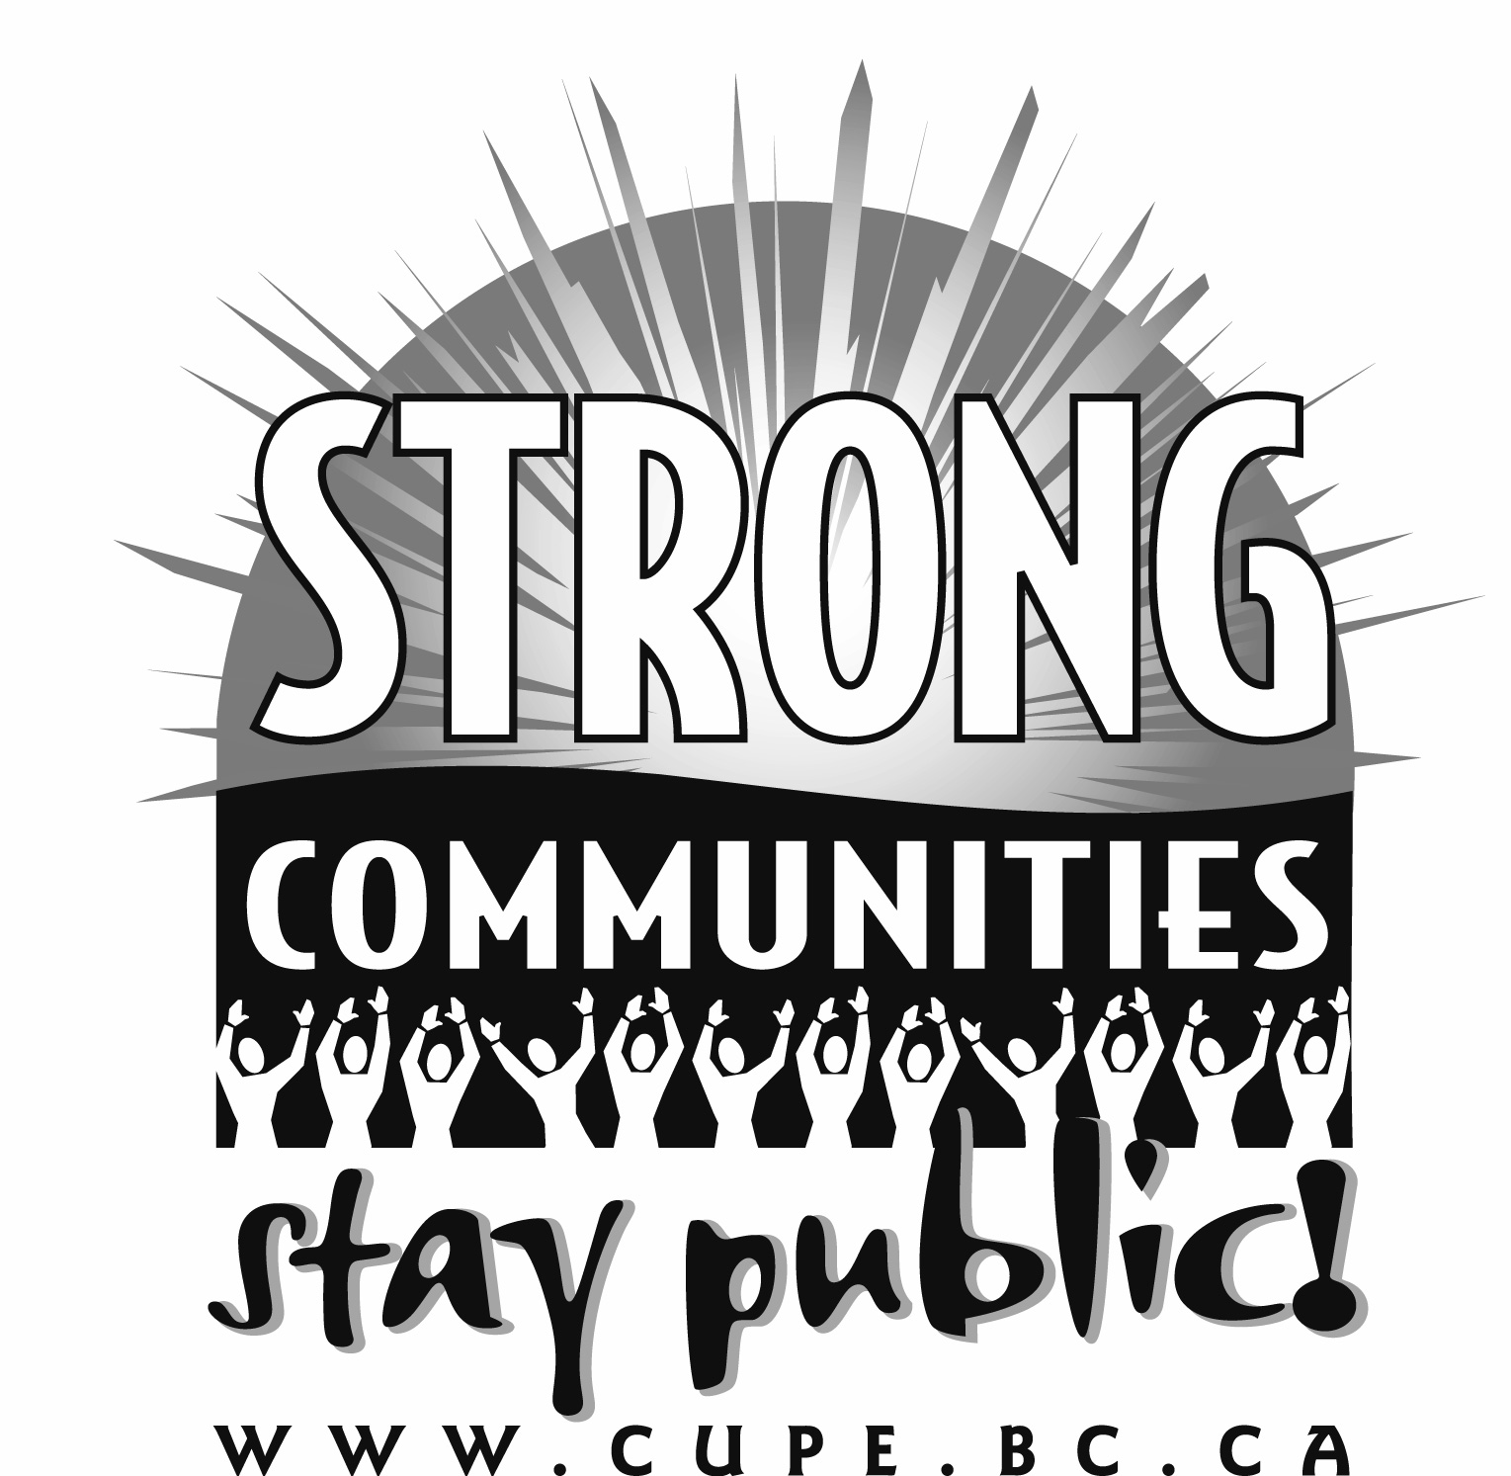
The shouts were so loud, they woke themselves up…and once again they picked up their shovels and hoe’s and began to build a City. Now on a calm day, with the wind just right….you can hear the town-folk while they work away the hours….

“We built it, we’ll keep it!….we built it, we’ll keep it!”

And they all lived happily ever after.

